

**Frankfurt University of Applied Sciences**

Faculty of Electrical Engineering

Bachelor Thesis

Design, Implementation, and Characterisation

of an Autonomous Wireless Agrometeorology Station

submitted by

Do Nguyen Hoang

Matriculation number: 1235052

|  |  |  |
| --- | --- | --- |
| Supervisor | : | Dr.-Ing. Udo Klein |
| Second supervisor | : | M.Sc. Tran Quang Nhu |

*(This page is intentionally left blank)*

# Disclaimer

I declare that this report is the product of my work, unless otherwise referenced. All opinions, result, conclusions, and recommendations are my own to the best of my knowledge and may not represent the policies or opinions of the Vietnamese-German University.

_____________________

Do Nguyen Hoang

# Abstract

Precision agriculture is the key for productivity. However, it cannot be achieved via traditional methods of human observations and experience, which are still widely applied while technological advances remain in the uncharted territories. This project aims at building a sensor system that can remotely monitor the meteorology of a farming area with a high precision and consistency.

The main objective of this design is the development of a self-contained system running with little to no human intervention. The system features a collection of sensors to sample targeted environment parameters and allows the data to be accessed online, while remaining off-grid, at a minimum cost. The conceptual design suggests the viability of a such goal, though not without constraints.

# Table of Contents

Disclaimer i

Abstract ii

Table of Contents iii

List of Figures v

List of Tables vii

Abbreviations viii

1. Introduction 1

1.1. Background 1

1.2. Objectives 1

1.3. Thesis structure 1

2. Module overview 2

2.1. STM32F103C8T6 Microcontroller 2

2.2. Sensor Units 3

2.2.1. Anemometer 3

2.2.2. Wind Vane 4

2.2.3. Rain Gauge 6

2.2.4. BME280 8

2.2.5. DS18B20 10

2.3. SX1278 for Wireless Communication 11

2.4. Other Modules 13

2.4.1. DS3231 13

2.4.2. Analogue Low-pass Filter (LPF) 14

2.5. System Powering 17

2.6. Server 17

3. Implementation 19

3.1. STM32F103C8T6 Microcontroller 19

3.2. Anemometer 20

3.3. Wind Vane 23

3.4. Rain Gauge 28

3.5. BME280 29

3.6. DS18B20 30

3.7. SX1278 31

3.8. DS3231SN 32

3.9. System Powering 32

4. Software design 35

4.1. Anemometer 35

4.2. Wind Vane 35

4.3. Rain Gauge 36

4.4. BME280 37

4.5. DS18B20 38

4.6. SX1278 40

4.7. DS3231SN 42

4.8. Server 43

5. Experimental Characterisation 45

5.1. Wind Vane 45

5.2. Temperature Sensing Units 48

5.3. Humidity Sensing Unit 51

5.4. InfluxDB Online Database 52

6. Conclusion and Future Work 54

References ix

# List of Figures

Figure 2‑1. The STM32F103C8T6-based Blue Pill board in the project 2

Figure 2‑2. The counterfeit read as an STM32F103 Medium Density device with a 128-KB Flash memory 3

Figure 2‑3. The three-cup anemometer [1] 4

Figure 2‑4. “The internal reed switch of the anemometer” [1] 4

Figure 2‑5. The wind vane [1] 5

Figure 2‑6. Electrical circuit of the wind vane [1] 5

Figure 2‑7. Examples of wind vane-reading circuits 6

Figure 2‑8. The structure of the rain gauge [1] 7

Figure 2‑9. Rain gauge’s reed switch on a PCB upon removal of base chassis cover cap [1] 7

Figure 2‑10. Orifice dimensions (in mm) of the funnel [1] 7

Figure 2‑11. Dimensions of a BME280 sensor [18] 8

Figure 2‑12. BME280 module with header strip [21] 9

Figure 2‑13. DS18B20 hardware 10

Figure 2‑14. Circuitry examples for communication with DS18B20 [1], [24] 11

Figure 2‑15. SX1278 LoRa module in test 13

Figure 2‑16. DS3231SN pinout module 14

Figure 2‑17. Passive first-order RC LPF circuit 15

Figure 2‑18. Frequency response of an example RC LPF with $R = 1 kΩ$ and $C = 100 nF$ under simulation 16

Figure 2‑19. Concept of the solar powering system 17

Figure 2‑20. The nodeMCU ESP8266 used at the server side of the project [1] 18

Figure 3‑1. The schematic of the STM32F103C8T6-housed Blue Pill board [7] 19

Figure 3‑2. Simplified Blue Pill schematic with removed unused parts 20

Figure 3‑3. Circuitry for testing the anemometer in ideal conditions 21

Figure 3‑4. An instance of noise spikes captured in an oscilloscope 21

Figure 3‑5. Reed switch debounced by an RC LPF (fc = 1.026 kHz) 21

Figure 3‑6. Reed switch debounced by a 200-nF capacitor 22

Figure 3‑7. Anemometer reading circuit 23

Figure 3‑8. A noise instance captured during a test on the wind vane 24

Figure 3‑9. Frequency response of the 1.013-kHz RC LPF 26

Figure 3‑10. Step response of the 1.013-kHz RC LPF 27

Figure 3‑11. Circuitry for reading the wind vane 28

Figure 3‑12. Circuitry for interfacing with the rain gauge 29

Figure 3‑13. BME280 setup for the I2C protocol 29

Figure 3‑14. Insufficient power for DS18B20 in parasite mode due to voltage drop when master turns on MOSFET after releasing the 1-Wire bus 30

Figure 3‑15. Faulty data by only DS18B20 with MOSFET 2 30

Figure 3‑16. Inconsistency of data output by DS18B20 with MOSFET 1 as compared to Figure 33 30

Figure 3‑17. A defective result yielded due to software error for the first DS18B20 in parasite mode 31

Figure 3‑18. Hardware setup for SX1278 LoRa module 31

Figure 3‑19. Hardware setup with the DS3231SN RTC module 32

Figure 3‑20. Block diagram of the system powering circuitry 33

Figure 4‑1. Initialisation of an anemometer reading routine 35

Figure 4‑2. Software setup and data acquisition for the rain gauge 37

Figure 4‑3. Temperature conversion time by thermometer resolution 39

Figure 4‑4. Bit format of the raw temperature value [24] 40

Figure 4‑5. SX1278 software setup and message-handling routines 42

Figure 4‑6. Example of a dashboard providing visual element of sensor readings in InfluxDB 44

Figure 5‑1. The “N” indicator for North from Figure 4 46

Figure 5‑2. Wind vane test setups 46

Figure 5‑3. Distribution of wind vane resistance readings from the circuit without a LPF 47

Figure 5‑4. Distribution of wind vane resistance readings from the circuit with a LPF 48

Figure 5‑5. The digital hygrometer – thermometer FY-11 used as reference 49

Figure 5‑6. Temperature sensor behaviours from the first temperature data set 49

Figure 5‑7. Temperature sensor behaviours from the second temperature data set 50

Figure 5‑8. Humidity read by the reference FY-11 and the BME280 sensor in the first run 51

Figure 5‑9. Humidity read by the reference FY-11 and the BME280 sensor in the second run 51

Figure 5‑10. The InfluxDB dashboard displaying sensor readings from BME280 53

# List of Tables

Table 1. Wind directions by resistor values [15] 6

Table 2. BME280 setup parameters [19] 10

Table 3. Comparison of different wireless communication technologies for IoT in Vietnam [33]–[37] 12

Table 4. Instances of rising and falling time of signals by the reed switch 22

Table 5. Wind vane ADC input signals by current mirror with $I0=27.59 μA$ 23

Table 6. Wind vane ADC input signals by voltage divider with $Rexternal=3.3 kΩ$ 24

Table 7. Quantity of ineffective LS bits by DS18B20’s thermometer resolution 40

Table 8. LoRa I and Q signals for a gateway and a node [70] 42

Table 9. Thresholds of neighbouring resistance values from Table 1 46

# Abbreviations

|  |  |  |
| --- | --- | --- |
| GDP | Gross Domestic Product | |
| IoT | Internet of Things |  |
| ADC | Analogue-to-Digital Converter | |
| I2C | Inter-Integrated Circuit | |
| U(S)ART | Universal (Synchronous) Asynchronous Receiver/Transmitter | |
| SPI | Serial Peripheral Interface | |
| PCB | Printed Circuit Board | |
| RH | Relative Humidity |  |
| IIR | Infinite Impulse Response | |
| 1-Wire | One-Wire |  |
| MOSFET | Metal-Oxide Semiconductor Field-Effect Transistor | |
| LoRa | Long-Range |  |
| Wi-Fi | Wireless Fidelity |  |
| NFC | Near Field Connection | |
| RFID | Radio-frequency Identification | |
| RTC | Real-time Clock |  |
| TCXO | Temperature-compensated Crystal Oscillator | |
| LPF | Low-pass Filter |  |
| MS | Most Significant |  |
| LS | Least Significant |  |
| LoRaWAN | Long Range Wide Area Network | |
| ISR | Interrupt Service Routine | |
| CSV | Comma-separated Values | |
| ROM | Read-only Memory |  |

# Introduction

## Background

## Objectives

The main objective of this project is to develop a concept for an Autonomous Wireless Agrometeorology Station, so a working prototype is not necessary. However, the viability of each included module may need evaluations via a practical approach.

In general, the Autonomous Wireless Agrometeorology Station should satisfy the following requirements:

* The station is automatic and operates off-grid.
* The station is able to monitor the following parameters and send the readings wirelessly to a server once every 5 minutes.
  + Temperature at ground level and 1 metre abovr the ground within the range of -50 ℃ to 70 ℃ at a resolution of 0.04 ℃ with an accuracy of at least 0.5 ℃.
  + Barometric pressure within the range of 900 hPa to 1100 hPa at a resolution of 0.5 hPa with an accuracy of at least 4 hPa.
  + Humidity within the range of 0 %RH to 100 %RH at a resolution of 0.03 %RH with an accuracy of at least 3.5 %RH.
  + Wind direction by at least 8 principle directions, including the 4 basic cardinal directions of North, East, South, West, and the 4 ordinal directions Northeast, Southeast, Southwest, Northwest.
  + Wind speed with a maximum of 25 m/s and a relative accuracy of 1%
  + Precipitation data at the site of installation.
* The station is able in the Southeast Asia region.
* The station is small and simple enough to be deployed by 1 person with little to no experience.

## Thesis structure

# Module overview



## STM32F103C8T6 Microcontroller

There are numerous factors when it comes to choosing a microcontroller for a project, including the project requirements, physical and electrical characteristics of a microcontroller (size, architecture, built-in features, upgradability, etc.), development platforms, and supply chain factors (cost and availability) [1]–[5]. Based on the objectives of this thesis (Section 1.2) and the characteristics of other modules explored later in this chapter, it is determined that the microcontroller of choice must have at least 19 port pins that have the capability for handling GPIO, external interrupts, ADC, SPI, and I2C. Furthermore, since this thesis has a side objective of testing the STM32duino firmware, the options are limited to the STM32 family by STMicroelectronics.

All the devices belonging to the STM32 family run on a 2.0-3.6V power supply, which is relatively more power-efficient than higher-voltage microcontrollers (i.e., the 5-V AVR family) [6]. For testing and prototyping, one of the popular STM32 options in Vietnam that satisfies the port pin quantity requirement is the STM32F103C8T6 available on a Blue Pill board. However, upon purchased, the units appear to contain a counterfeit (Figure 2‑1) which bears much similarities with an authentic STM32F103C8T6 apart from its doubled Flash memory size of 128 KB (Figure 2‑2). For the sake of simplicity, this thesis shall still call the counterfeit an STM32F103C8T6 microcontroller.

|  |  |
| --- | --- |
|  |  |
| (a) The Blue Pill board in testing and prototyping | (b) The counterfeit with the markings   like an authentic STM32F103C8T6 |

Figure 2‑1. The STM32F103C8T6-based Blue Pill board in the project

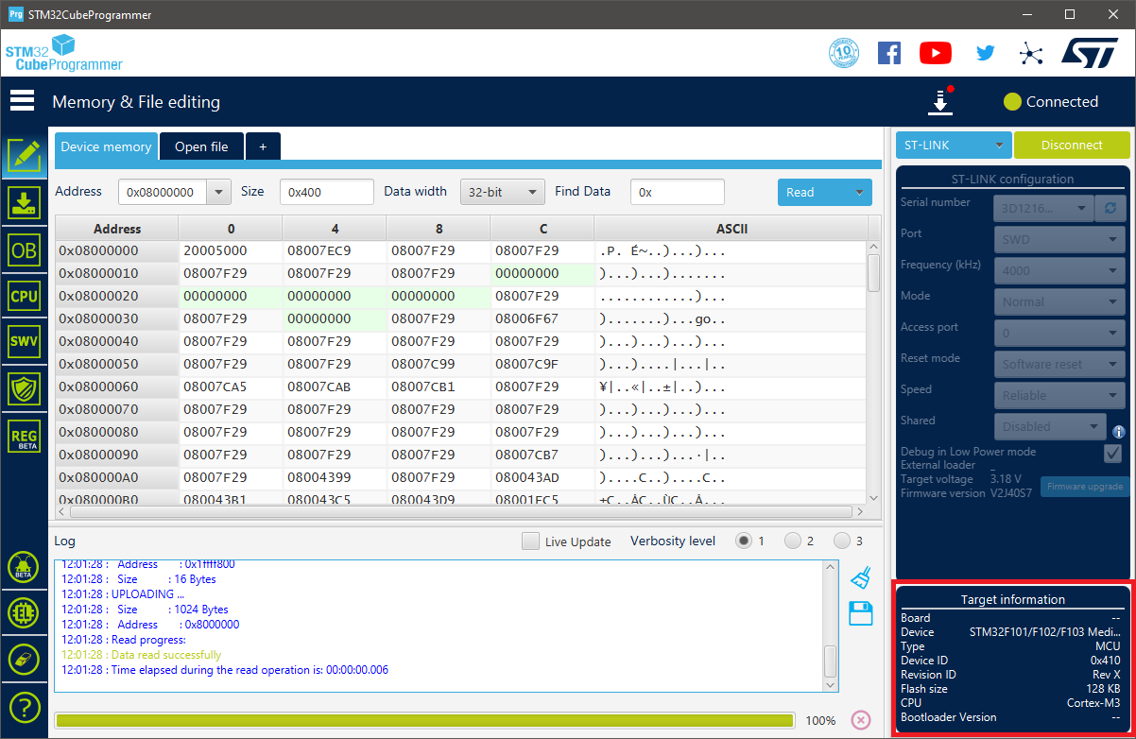

Figure 2‑2. The counterfeit read as an STM32F103 Medium Density device with a 128-KB Flash memory

Each Blue Pill board offers 32 input/output port pins available for use with interrupt capability, 18 of which are 5-V tolerant [7]–[9]. The STM32F103C8T6 microcontroller is built with 2 12-bit Analogue-to-Digital Converter (ADC) modules sharing 10 physical input pins (from PA0 to PA7, and PB0, PB1), 7 timers whose resolutions range from 16-bit to 24-bit, and remappable communication interfaces including I2C, U(S)ART, and SPI. As a result, the STM32F103C8T6 is determined to be able to handle communications with other devices used in this design.

## Sensor Units

In agriculture, the weather factor plays a key role in the growth and development of plants, since it affects both the environment (e.g., soil, fungi, pests) and the plants themselves (e.g., the integrity of branches and leaves) [10]–[12]. By monitoring the corresponding meteorological parameters, agronomy helps to predict weather events and to plan suitable adjustments to an area for the maximised agric productivity. Some such qualities includes wind data, rainfall, temperature, humidity, and atmospheric pressure, which are to be monitored by the Autonomous Wireless Agrometeorology Station via a set of sensors which are looked into in this section.

### Anemometer

The Autonomous Wireless Agrometeorology Station includes a sensor kit SP-WS02 for the Wireless Weather Station WH2081 by Misol Electronics. The kit consists of a thermo-hygrometer, an anemometer, a wind vane, and a rain gauge [13]. However, the temperature – humidity sensor is not used since it is of unknown type and encased along with the processing unit of Misol’s Weather Station. Section 2.2 therefore explores the other 3 devices, first of which is the anemometer for reading wind speed.

The anemometer follows the standard design for 3-cup anemometers, which was built to replace the traditional 4-cup design due to its superior aerodynamic performance [14], with an addition of a magnet and a reed switch. The leads of the reed switch is further extended by an RJ11 cable to allow reading of the switch electrically with a suitable circuitry.

|  |  |
| --- | --- |
| 3.85 cm  (inner) | 9.2 cm |
| 1. Side view | 1. Top view |

Figure 2‑3. The three-cup anemometer [1]

|  |  |
| --- | --- |
|  |  |
| 1. The internal reed switch shown upon   the removal of bottom cap | 1. The connection between the reed switch and the RJ11 connector [15] |

Figure 2‑4. “The internal reed switch of the anemometer” [1]

The reed switch is observed to be normally open upon removal of the PCB (Figure 2‑4a) from the sensor body. When the magnet fixed under the rotor passes, the reed switch produces a click, based on which it is found to close twice per revolution of a cup.

### Wind Vane

The second device from the sensor kit SP-WS02 is a wind vane for reading wind directions. Underneath the rotor of the wind vane is there a magnet which closes up to 2 out of 8 normally-open reed switches on the PCB inside the body of the sensor (Figure 2‑6). Each reed switch is paired with a unique resistor whose value is read to determine the position of the rudder blade, thus the wind direction.

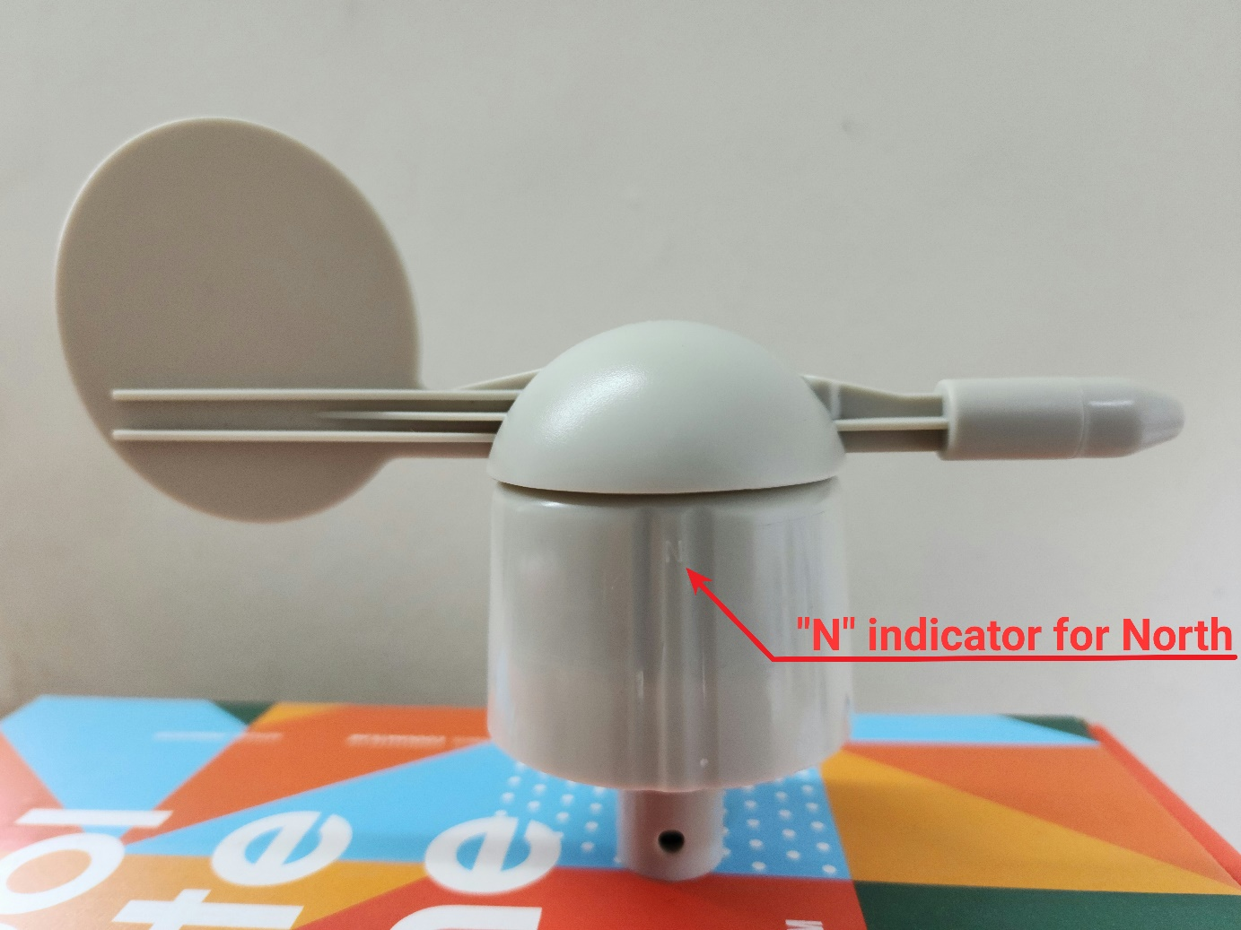

Figure 2‑5. The wind vane [1]

|  |  |
| --- | --- |
|  |  |
| 1. Reed switches inside the wind vane | 1. Schematic of the wind vane’s circuit from [15] |

Figure 2‑6. Electrical circuit of the wind vane [1]

The wind vane has an RJ11 port for users to connect the anemometer and combine the 2 sensors into 1 output via the wind vane’s RJ11 cable as illustrated in Figure 2‑6b. When set up accordingly to the 4 directions marked on the sensor’s body, the aforementioned resistors give the direction as shown in Table 1. It has been pointed out that the magnet could close 2 reed switches simultaneously, thus parallel resistors formed and 8 additional wind directions to be read.

|  |  |  |  |  |  |  |  |
| --- | --- | --- | --- | --- | --- | --- | --- |
| Direction (single resistor) | | | R | Direction (parallel resistors) | | | R |
| Cardinal point | | Azimuth degrees | Cardinal point | | Azimuth degrees |
| North | N | 0˚ | 33 KΩ | North-Northeast | NNE | 22.5˚ | 6.57 KΩ |
| Northeast | NE | 45˚ | 8.2 KΩ | East-Northeast | ENE | 67.5˚ | 891 Ω |
| East | E | 90˚ | 1 KΩ | East-Southeast | ESE | 112.5˚ | 688 Ω |
| Southeast | SE | 135˚ | 2.2 KΩ | South-Southeast | SSE | 157.5˚ | 1.41 KΩ |
| South | S | 180˚ | 3.9 KΩ | South-Southwest | SSW | 202.5˚ | 3.14 KΩ |
| Southwest | SW | 225˚ | 16 KΩ | West-Southwest | WSW | 247.5˚ | 14.12 KΩ |
| West | W | 270˚ | 120 KΩ | West-Northwest | WNW | 292.5˚ | 42.12 KΩ |
| Northwest | NW | 315˚ | 64.9 KΩ | North-Northwest | NNW | 337.5˚ | 21.88 KΩ |

Table 1. Wind directions by resistor values [15]

Table 1 data is given by Argent Data Systems and verified by the use of a multimeter. In a microcontroller-based system, reading resistor value, thus the wind direction, from the wind vane could be done by mimicking the behaviour of a multimeter in resistance measurement mode: injecting a constant current to get a voltage across the internal resistors [16]. Another approach is to use an external resistor to form a voltage divider [15]. Either way, the resistive value accoss the RJ11 inductors of the wind vane must be determined by an ADC module.

|  |  |
| --- | --- |
|  |  |
| 1. Current mirror circuit as  a constant current source | 1. Voltage divider with an external resistor |

Figure 2‑7. Examples of wind vane-reading circuits

### Rain Gauge

The third device from the sensor kit SP-WS02 used in this project is a rain gauge as a self-emptying tipping bucket. It is comprised of 2 small buckets mounted on a fulcrum like a seesaw underneath a funnel (Figure 2‑8). The design allows the buckets to tip over a side when one is full to be emptied through the opennings on the base of the rain gauge, while the other in turn collects rain water. The magnet fixed to the bucket (Figure 2‑8b), on the other hand, also moves pass the reed switch hidden inside the case on the rain gauge base and momentarily closes it. Since the reed switch leads are extended via an RJ11 cable, with a suitable circuitry, electrical pulses could be generated and read by the microcontroller.

|  |  |
| --- | --- |
|  |  |
| 1. Top view: the orifice of the funnel | 1. Disassembly: the buckets on a pivot |

Figure 2‑8. The structure of the rain gauge [1]

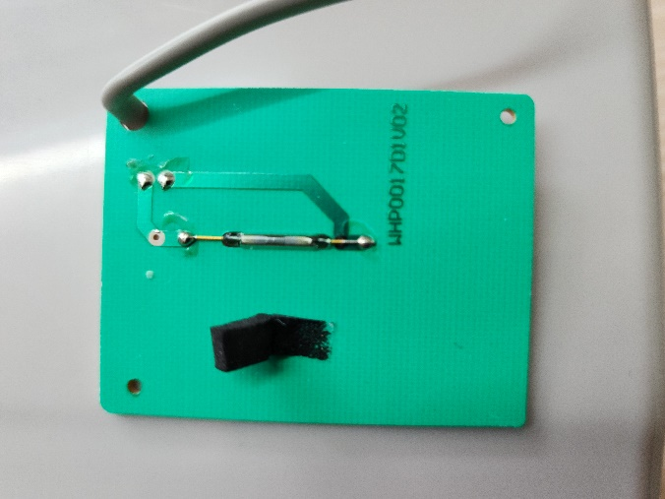

Figure 2‑9. Rain gauge’s reed switch on a PCB upon removal of base chassis cover cap [1]

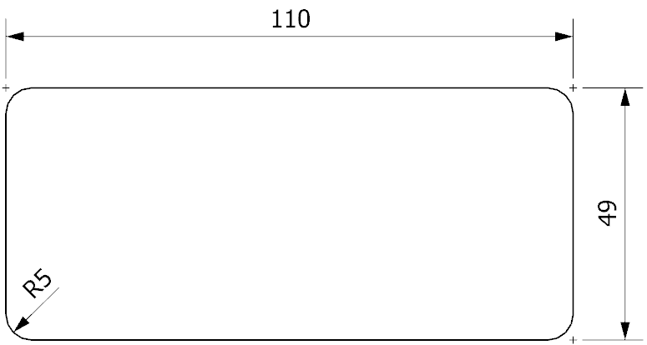

Figure 2‑10. Orifice dimensions (in mm) of the funnel [1]

Misol Electronics states that the rain gauge produces 1 pulse for every 0.3 mm of rain [17], while Argent Data System provides a value of 0.011”, or 0.2794 mm [15]. However, since the resolution provided by the latter is converted from inches, the difference may be neglected, and the value of 0.3 mm rainfall per tip could later be used to construct the software for the Autonomous Wireless Agrometeorology Station.

### BME280

BME280 is a self-calibrating environmental sensor by Bosch Sensortec GmbH. It is a combined digital sensor for barometric pressure, relative humidity, and ambient temperature, developed for multiple targets including mobile devices and wearables, thus the advantages of small size and low power consumption [18], [19]. Since the Autonomous Wireless Agrometeorology Station is supposed to be able to provide data on temperature 1 metre above the ground, air pressure, and humidity, the BME280 appears to be a good option for minimal space usage on an off-grid system. Moreover, although there are other alternatives of the same features and functionalities (e.g., MS8607 [20]), the BME280 has been found to be the only available solution on the market in Vietnam. The device in this conceptual design, however, arrives as a PCB module with a 2.54-mm single row header strip for convenience in prototyping and testing.

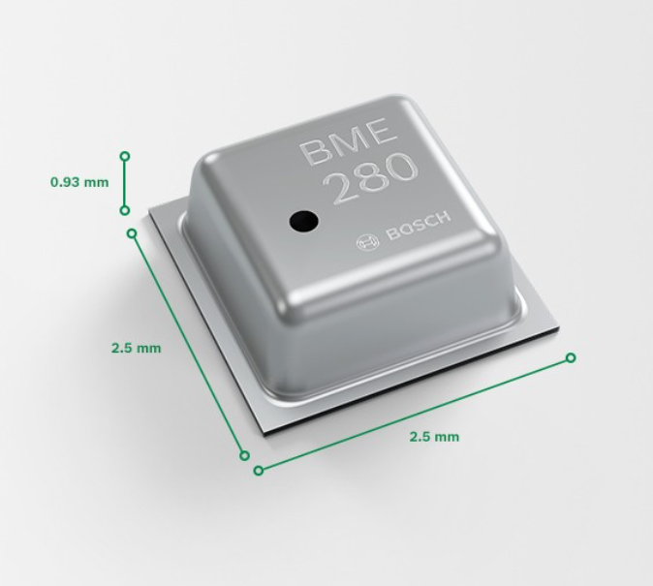

Figure 2‑11. Dimensions of a BME280 sensor [18]



Figure 2‑12. BME280 module with header strip [21]

According to [19], the product specifications of the BME280 are as follows:

* Operational voltage: 1.71 V to 3.6 V
* Communicational voltage: 1.2 V to 3.6 V
* Typical current consumption: 0.1 µA (sleep mode) to 714 µA (pressure measurement)
* Full-range output:
  + Temperature: -40 ℃ to +85 ℃
  + Humidity: 0 %RH to 100 %RH
  + Pressure: 300 hPa to 1100 hPa
* Data resolution:
  + Temperature: 0.01 ℃
  + Humidity: 0.008 %RH
  + Pressure: 0.18 hPa (minimum)
* Data accuracy:
  + Temperature: ±0.5 ℃ (0 ℃ to 65 ℃) up to ±1.5 ℃ (-40 ℃ to -20 ℃)
  + Humidity: ±3 %RH
  + Pressure: ±1 hPa

As an IC sensor, the BME280 is built with not only the sensing units but also mode control, data compensation, and noise reduction by oversampling and a digital filter. During software setup, the BME280 could be configured with the parameters shown in Table 2.

|  |  |
| --- | --- |
| Parameter | Valid values |
| Sensor mode | Sleep mode, Normal mode, Forced mode |
| Pressure sampling rate | None (sampling is turned off), x1, x2, x4, x8, x16 |
| Temperature sampling rate |
| Humidity sampling rate |
| IIR filter coefficient | Off (IIR filter is turned off), x2, x4, x8, x16 |
| Standby time for normal mode (in milliseconds) | 0.5, 10, 20, 62.5, 125, 250, 500, 1000 |

Table 2. BME280 setup parameters [19]

Apart from the size and specifications, one of the advantages of the BME280 is that it has 2 communication protocols, SPI and I2C, which provides flexibility in integrating the sensor to a microcontroller system. Furthermore, software interfacing with the device is fully supported in Arduino platform of this project via a collection of libraries developed and contributed by the community from the driver by Bosch Sensortec GmbH [22].

### DS18B20

DS18B20 is a family of digital temperature sensors by Maxim Integrated that follows the design of DS1820, a predecessor introduced by Dallas Semiconductor in 1998 [23]. Although the DS18B20 sensors are offered in only 3 types of packages by the manufacturer [24], a waterproof version with a long cable built from the 3-pin TO-92 configuration DS18B20 is available and has had its application explored off a PCB in different environments (e.g., liquids) [23], [25]–[27]. Because of this version, the DS18B20 is chosen to monitor the ambient temperature at ground level for this project. Although there are other choices of sensors with long cables, they either need heavily calibrating (e.g., Resistance Temperature Detector PT100 [28]), or have higher price and unnecessary functions (e.g., the AM2315 temperature and humidity sensor priced at 830,000 VND compared to the 71,000-VND DS18B20 temperature sensor with 1-m long cable [29], [30]).

|  |  |
| --- | --- |
|  |  |
| 1. TO-92 configuration | 1. Waterproof version with 1-m long cable |

Figure 2‑13. DS18B20 hardware

According to [2], the specifications of the sensor are as follows:

* Operating voltage: 3.0 V to 5.5 V
* Active current: typically, 1 mA (VDD = 5 V)
* Standby current: typically, 750 nA
* Sink current: maximum, 4.0 mA
* Full-range temperature output: -55 ℃ to +125 ℃
* Data resolution: programmable; 0.5 ℃, 0.25 ℃, 0.125 ℃, and 0.0625 ℃
* Minimum thermometer error: ±0.5 ℃ (from -10 ℃ to +85 ℃)

Communication with a DS18B20 is done asynchronously via the bi-directional One-Wire (1-Wire) protocol, which works under the principle of timing, digital input/output, and interchanging control of a single wire among masters (microcontrollers) and slaves (1-Wire devices). Although the standard communication speed is announced to be a maximum of 16.3 kbps, a high-speed mode “overdrive” of up to 90 kbps is available [31], [32]. The 1-Wire protocol allows a DS18B20 to operate not only on an external power supply but also in a parasite mode as depicted in Figure 2‑14 for lower power consumption [24]. However, it is found that the circuitry in Figure 2‑14b is only applicable if the microcontroller turns on the MOSFET before releasing the 1-Wire bus for the sensor when required. Alternatively, the MOSFET could be replaced by software (Figure 2‑14c) when the microcontroller outputs “HIGH” on its digital pin of the 1-Wire bus as soon as releasing control.

|  |  |
| --- | --- |
|  | |
| (a) DS18B20 on an external power supply | |
|  |  |
| (b) DS18B20 in parasite mode with a MOSFET | (c) DS18B20 in parasite mode  (software-controlled) |

Figure 2‑14. Circuitry examples for communication with DS18B20 [1], [24]

## SX1278 for Wireless Communication

For this conceptual design of an Autonomous Wireless Agrometeorology Station, the wireless communication between the station and a server is done via LoRa. The choice for LoRa is done from the comparison below.

|  |  |  |  |
| --- | --- | --- | --- |
| Technology | Highest data rate (uplink) | Maximum coverage | Power consumption |
| Wireless Fidelity (Wi-Fi) | 93.38 Mbps | 90 m | Medium to high |
| Bluetooth | 1 – 3 Mbps | 100 m | Low |
| Cellular network | 18.27 Mbps | Several kilometres | Medium to high |
| LoRa | 37.5 kbps | Several kilometres | Low |
| Zigbee | 250 kbps | 50 m | Low |
| Near Field Communication (NFC) | 424 kbps | 10 cm | Low |
| Radio-frequency Identification (RFID) | 424 kbps | 10 cm | Low |

Table 3. Comparison of different wireless communication technologies for IoT in Vietnam [33]–[37]

It could be observed that Wi-Fi provides the highest communication speed, while data-exchange is slowest via LoRa. The data collected and transmitted by the system are just sensor readings, so the data rate does not need to be high [38].

The next criterium to be taken into account is the range over which communications are performed. LoRa and Zigbee could be seen to allow data exchange range. Despite the maximum range of 90 m, Wi-Fi signals could typically reach a maximum of only 45 m [39], which should not be a problem for an agricultural application. The common Bluetooth modules HC-05 and HC-06 provide a connection up to 100 m [40], so Bluetooth remains an option. Only NFC and RFID technologies are invalid since they are applicable for only short-range communications.

In terms of power consumption, Wi-Fi and cellular network are not ideal for a self-contained off-grid design. Bluetooth, in spite of the low power consumption, is said to be more “power hungry” compared to LoRa [41]. That leaves LoRa and Zigbee the remaining choices for wireless communications.

For this project, LoRa and Zigbee are lastly compared over product prices. A major supplier in Ho Chi Minh City, Vietnam chosen for referencing is Thegioiic. The LoRa modules SX1278 are sold at around 100,000 VND, while prices for the Zigbee modules go from 183,000 VND [42], [43]. As a result, LoRa is the wireless communication technology chosen for this design, and 2 LoRa modules SX1278 are picked for the station and the server side. Each module is a PCB module with an 8-pin 2.54-mm dual row header strip for convenience in prototyping and testing.

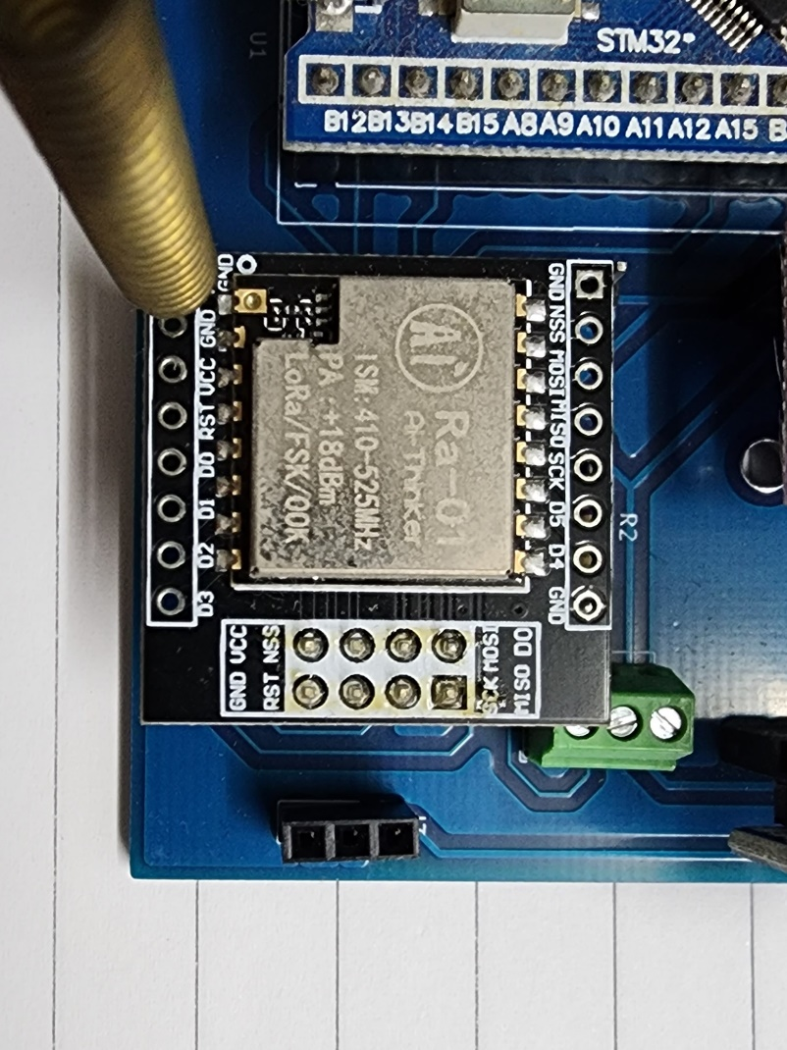

Figure 2‑15. SX1278 LoRa module in test

The product specifications for LoRa mode from [44] are as follows:

* Operating voltage: 1.8 V to 3.7 V
* Current consumption: 0.2 µA (sleep mode), up to 12 mA in receive mode or 120 mA during data transmissions
* Communication protocol: SPI
* Spreading factors: 6 to 12
* Cyclic coding rate: 4/5 to 4/8
* Signal bandwidth (in kHz): 7.8, 10.4, 15.6, 20.8, 31.2, 41.7, 62.5, 125, 250, and 500
* Package preamble length (in symbols): 6+4 to 65535+4
* User-defined package synch word: 8-bit synch word

## Other Modules

### DS3231

Time keeping with a real-time clock (RTC) module is an extended feature for the Autonomous Wireless Agrometeorology Station. For some other modules to work as later explored in section 4, since clocking and timing introduce stress on the microcontroller’s resources and may reduce the overall performance of the whole system, the solution of an RTC is explored.

The DS3231SN is an RTC from the DS3231 product lines by Maxim Integrated. The device is clocked by a 32,768-Hz crystal; however, unlike other products (e.g., DS1302 and DS1307), the whole DS3231 family has their crystal clock source included internally, hence fewer external components required.

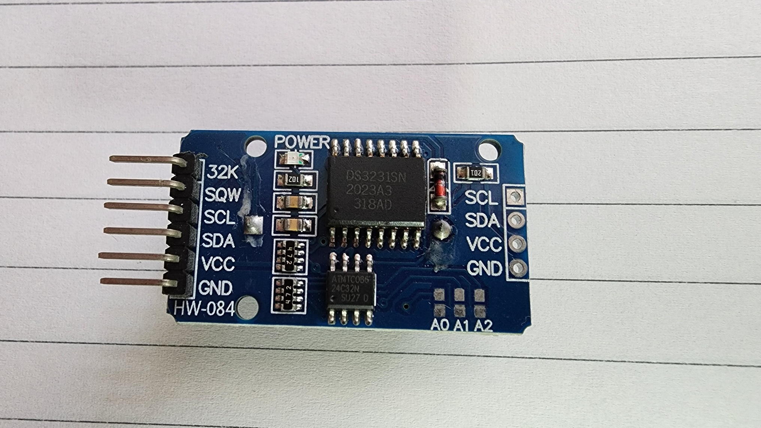

Figure 2‑16. DS3231SN pinout module

Another member from the DS3231 product lines is the DS3231M. A major difference between DS3231SN and DS3231M is that the former is built with a temperature-compensated crystal oscillator (TCXO) for the improved quality of time keeping [45], which could be checked via its 32K pin. As a result, the accuracy is proven to be much higher than that of the DS3231M [46]. Since DS1307 and DS1302 are essentially plain RTCs like the DS3231M, the DS3231SN is more accurate then these 2 options.

For testing purposes, a DS3231SN pinout module (Figure 2‑16) is used in this design. Positioned on the back of the module is a coin cell holder for a backup battery as suggested by the data sheet [47]. Should the battery be rechargeable (e.g., LiR2032), the power supply in the VCC pin need to be at least 1 V above battery voltage because of the protective 1N4148 diode and 200-Ω resistor; otherwise, either the diode or the resistor is to be removed to prevent any potential damage [46].

The key specifications of the DS3231SN from [47] are as follows:

* Operating voltage: 2.3 V to 5.5 V
* Battery voltage: 2.3 V to 5.5 V
* Maximum active current: 200 µA at 3.63 V
* Maximum standby current: 110 µA at 3.63 V
* Typical standby current from battery: 0.84 µA
* Effective time keeping range: from 1970 to 2100
* Compensated base clock output on 32kHz pin
* Programmable square wave output or alarm on pin
* I2C communication interface at up to 400 kHz

### Analogue Low-pass Filter (LPF)

In a real application, when dealing with electrical signals, one has to take into account the noise problem whose sources may vary from external interference to the components of a system itself [48], [49]. While an ideally clean signal is unachievable, noise reduction is not.

Noise is unwanted signals injected into the desired ones. As the result, one of the methods for noise reduction is to use filters. Since noise is usually at higher frequencies than the working signals of a system, it can be filtered out by a low-pass filter, which only allow signals with frequencies lower than the cut-off frequency of the circuit to pass to the output. The simplest filter against noise is a passive first-order RC LPF put between the signal source (e.g., a sensor) and the sampling device (e.g., a microcontroller).

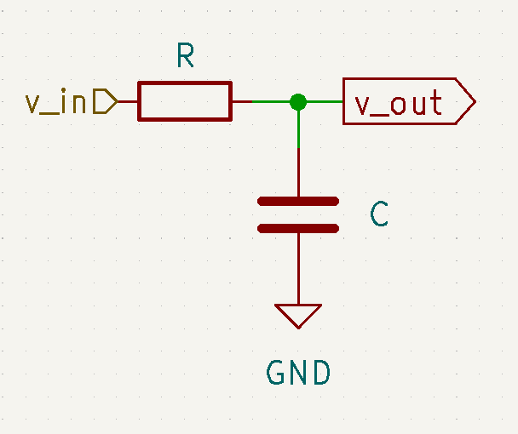

Figure 2‑17. Passive first-order RC LPF circuit

The circuit above acts under the principle of a voltage divider:

$\frac{v_out}{v_in}=\frac{Z_{C}}{Z}=\frac{Z_{C}}{\sqrt{R^{2}+Z_{C}^{2}}}$, where $Z_{C}=\frac{1}{2πfC}$ and $f$ is the frequency of the input signal $v_in$.

The cut-off frequency $f_{c}$ of a LPF is defined to be the frequency at which the voltage gain on the logarithmic scale of the output $A_{V}=20×log⁡(\frac{v_{out}}{v_{in}})$ is -3 dB [50], or $\frac{v_out}{v_in}=\frac{1}{\sqrt{2}}$. As the result, the cut-off frequency of a passive RC LPF is $f_{c}=\frac{1}{2πRC}$. For example, a LPF with $R = 1 kΩ$ and $C = 100 nF$ has the cut-off frequency $fc = 1591.55 Hz$.

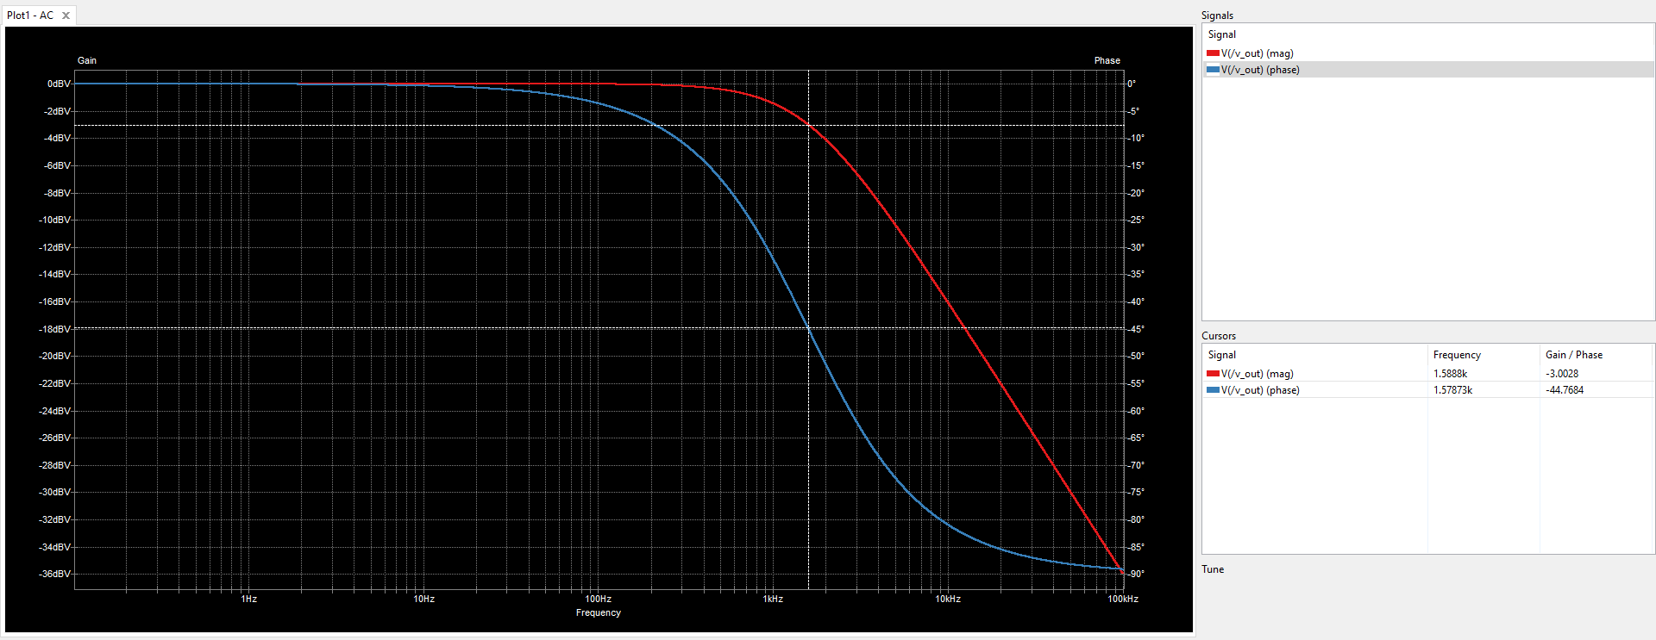

Figure 2‑18. Frequency response of an example RC LPF with $R = 1 kΩ$ and $C = 100 nF$ under simulation

## System Powering

One of the requirements for the Autonomous Wireless Agrometeorology Station is that it is able to operate off-grid. In order to do that, the system needs another power source. Some possible solutions are solar power, wind energy, and replaceable batteries.

For a system running solely on batteries, there arise some potential issues:

* System downtime during battery replacement, or when the batteries are drained,
* Requirement to constantly monitor the battery voltage to alarm an operator in case replacement is in place,
* Difficulty in approaching the station site during extreme weathers like rains or storms,
* And availability of a human operator.

The quality of meteorological monitoring depends heavily on the uptime of the sensor node, so the potential downtime rules out the battery solution.

Wind and sun are among the renewable power sources, and have high availability. Ideally, the sensor station is installed on an open field, so access to these power sources is not difficult. However, solar energy cannot be harvested at night, while wind energy requires the use of wind turbines that are usually bulky. Out of the two, the solar power solution appears to be a better option by including a battery unit to overcome its forementioned disadvantage.

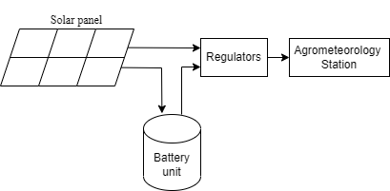

Figure 2‑19. Concept of the solar powering system

## Server

The server side for the Autonomous Wireless Agrometeorology Station consists of:

* A gateway that receives the sensor data wirelessly from the station via LoRa communication,
* And an online database which the gateway forwards the sensor data to and makes the data accessible for users.

The main idea is to involve another microcontroller to use with an SX1278 LoRa module as the gateway. The microcontroller should be able then to connect to the Internet to upload the received data to the online database of choice.

For the sake of simplicity, a nodeMCU ESP8266 is utilised because of its Wi-Fi connection capability and its availability, as well as the Arduino framework for software development. The online database of choice is ThingSpeak by The MathWorks Incorporation, on top of services like Microsoft Azure, Google Firebase, and InfluxDB.

Initially, InfluxDB was in use as the online database for the Autonomous Wireless Agrometeorology Station and proved to be intuitive [1]. However, it is discovered that this service only retains uploaded data for 30 days for free accounts, which makes it less ideal for a project of a bachelor thesis. Microsoft Azure and Google Firebase, on the other hand, offer decently free services, but the connection proccesses are quite complicated, thus ruled out. ThingSpeak is the remaining option whose service is free of charge while letting users accessing and handling data without a time limit. The only known downside of ThingSpeak is that each free account is only allowed 4 data channels, which is not an issue in testing and prototyping the Autonomous Wireless Agrometeorology Station.

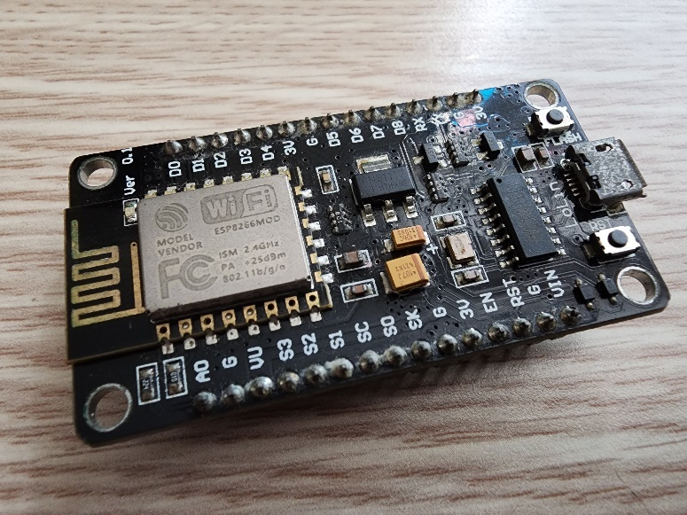

Figure 2‑20. The nodeMCU ESP8266 used at the server side of the project [1]

# Implementation

## STM32F103C8T6 Microcontroller

As mentioned in section 2.1, the STM32F103C8T6 microcontroller in test is shipped on a Blue Pill board () with all the necessary components for its peripherals. However, the implementation in this thesis does not require some included blocks such as the RTC or the voltage regulator, thus some unused hardware pins and/or components. As a result, some parts are removed from the Blue Pill board for testing purpose; and later on, the board is redesigned following Figure 3‑2. The board is then implemented with all the connections shown in Figure 3‑3.

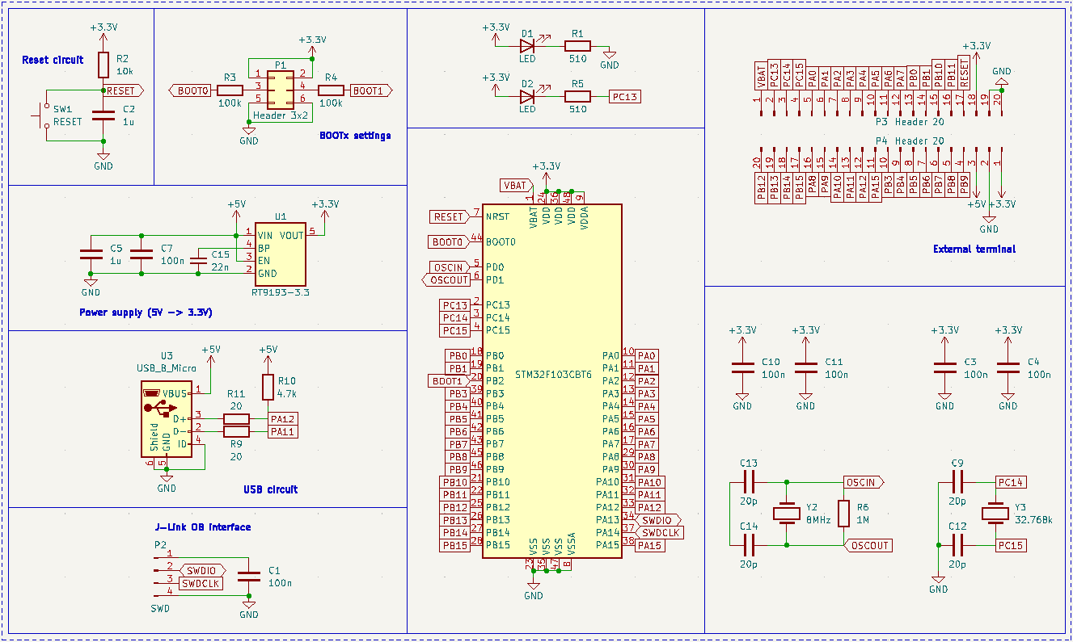

Figure 3‑1. The schematic of the STM32F103C8T6-housed Blue Pill board [7]

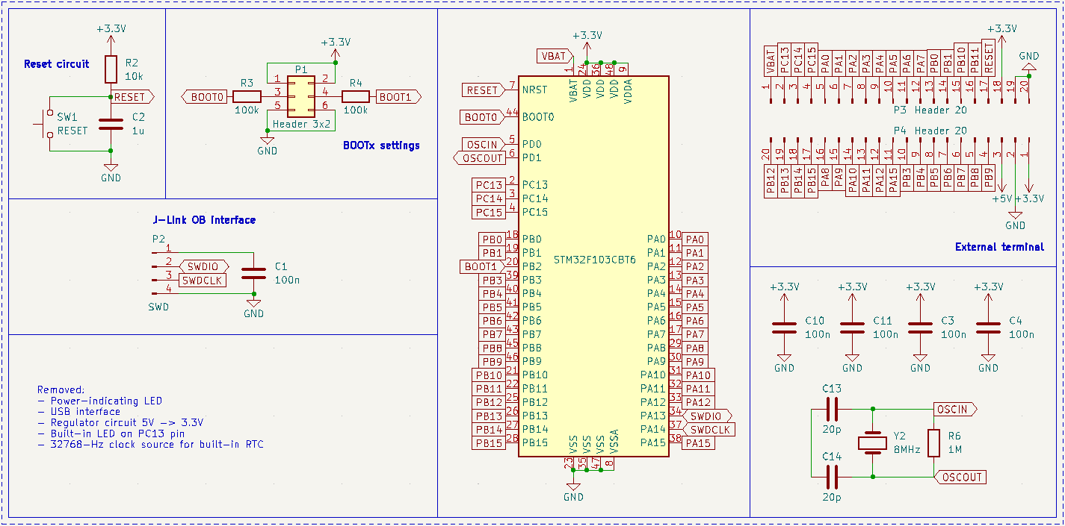

Figure 3‑2. Simplified Blue Pill schematic with removed unused parts

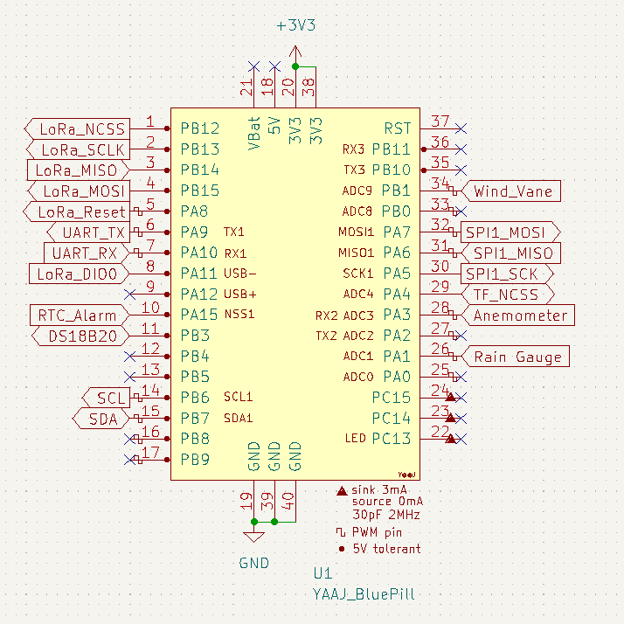

Figure 3‑3. Bus connections with the Blue Pill board

## Sensor units

### Anemometer

#### Hardware dependencies

##### Pull-up resistor

As mentioned in Section 2.2.1, the anemometer could be read through the inner 2 conductors of its RJ11 cable. If it is connected to the wind vane as shown in section 2.2.2, interfacing through the inner 2 conductors of wind vane’s RJ11 cable is done instead. It is known that the electronic part of the anemometer is a mechanical device called the reed switch. As a standalone device, a reed switch does not create any electrical signals to be read, thus the use of a setup as simple as illustrated in Figure 3‑4.

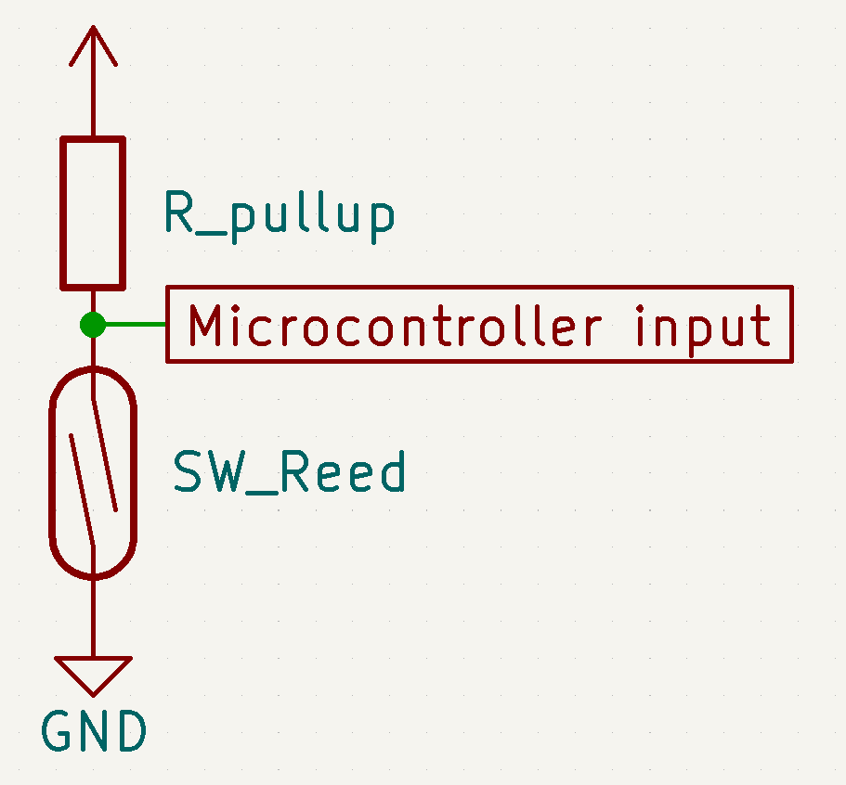

Figure 3‑4. Circuitry for testing the anemometer in ideal conditions

The circuitry in Figure 3‑4 generates active-LOW outputs by the use of the pull-up resistor, which means the microcontroller normally reads logic 1 and detects a logic 0 when the switch closes. Active-HIGH outputs could be achieved by switching the positions of the reed switch (SW_Reed) and the resistor (R_pullup); however, since there are potentially faults due to interference while the microcontroller detects logic 1 in that setup, active-HIGH signals are undesirable in this project.

The pull-up resistor value could be chosen for either strong or weak pull-up purpose. A resistor with a high value creates a weak pull-up which results in lower power consumption, and vice versa [51]. If the input impedance on the microcontroller pin is unknown, it is safe to choose a strong pull-up resistor (i.e. 4.7kΩ). However, [9] specifies that a resistor from 30kΩ to 50kΩ could be used to achieve a weak pull-up for an STM32F103CBT6 microcontroller, so the value of 33kΩ is chosen in this project. As a result, the design would be more suitable as a battery-powered application.

##### Bypass capacitor

In [1], [52], it is investigated that as a mechanical switch, a reed switch could produce noise spikes which yield wrong edge detections by a microcontroller, thus wrong data. For example, Figure 3‑5 illustrates a noise instance which could make a microcontroller read 3 falling edges instead of an expected 1 edge within a window of 98.98µs.

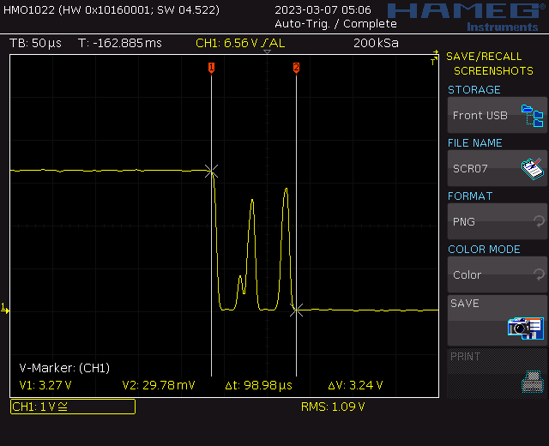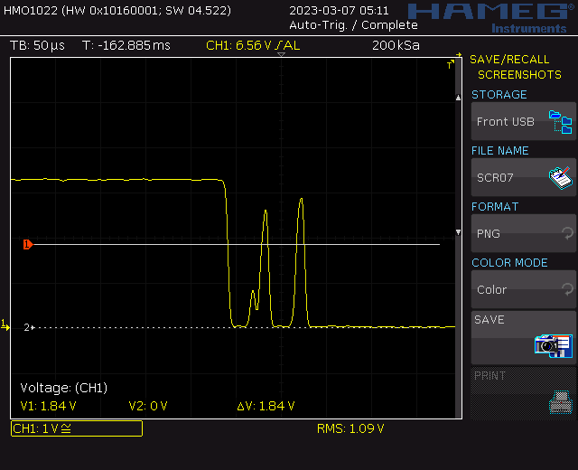

Figure 3‑5. “An instance of noise spikes captured in an oscilloscope” [1]

When noise spikes pass digital voltage threshold multiple times during 1 transition, a microcontroller may read more than 1 expected pulse, which yields wrong data. For a microcontroller with the “HIGH” voltage threshold being 1.8 V and the digital response frequency being as high as 18 MHz like a STM32F103C8T6 running at 3.3 V, noise spikes as shown in Figure 3‑4 produce 2 additional falling edges during that single 98.98-µs transition period. In such cases, either an RC LPF or a decoupling capacitor is effective against high frequency noise by producing a smooth transition.

|  |  |
| --- | --- |
|  |  |
| 1. Falling edge | 1. Rising edge |

Figure 3‑6. Reed switch debounced by an RC LPF (fc = 1.026 kHz)

Although Christoffersen demonstrates an RC LPF as a switch-debouncing solution [52], a full RC circuit may not be necessary. Following [53], a pair of pull-up resistor and capacitor could be chosen to satisfy that its time constant as below is about half of the debounce time.

|  |  |
| --- | --- |
| $T=R ×C$ where | $T$ (in seconds) is the time constant of the pull-up resistor – capacitor pair, |
| $R$ (in Ohms) is the value of the pull-up resistor of the switch circuit, |
| $C$ (in Farads) is the value of the decoupling capacitor. |

Since information from the anemometer is of digital input type, the voltage level after the pull-up resistor needs accounting for. According to [9], the voltage threshold for a “HIGH” input (VIH) is $0.42×\left(3.3 V-2 V\right)+1.3 V=1.833 V$, so the voltage drop across the pull-up resistor must not exceed $3.3 V – 1.833 V = 1.467 V$. Furthermore, the minimum current for a digital input is the maximum input leakage current of $1 µA$ [9], which yields the highest value for the pull-up resistor being $\frac{1.467 V}{1 μA}=1.467 MegΩ$. It is then safe to choose a common value of $10 kΩ$ for the pull-up resistor.

Reed switches have a relatively small bounce, but it is still up to 4.5 ms [54]. Consequently, the time constant goes up to $T=\frac{4.5 ms}{2}=2.25 ms$. The decoupling capacitor is then $C= \frac{T}{R}= \frac{2.25 ms}{10 kΩ}=225 nF$. Since a single-valued capacitor of 225 nF does not exist, the closest value of 220 nF is chosen.

|  |  |
| --- | --- |
|  |  |
| 1. Falling edge | 1. Rising edge |

Figure 3‑7. Reed switch debounced by a 200-nF capacitor

Both the LPF and the capacitor provide smooth transitions of the reed switch, but the juxtaposition of transition time makes the latter preferable for faster digital responses. Moreover, debouncing a mechanical switch with just a capacitor means less components, hence less space consumed on a PCB. The finalised circuitry for reading the anemometer is as Figure 3‑7.

|  |  |  |
| --- | --- | --- |
| Debouncing method | tfalling | trising |
| 1.026-kHz RC LPF | 1 ms | 12.44 ms |
| 200-nF capacitor | 10.71 µs | 9.48 ms |

Table 4. Instances of rising and falling time of signals by the reed switch

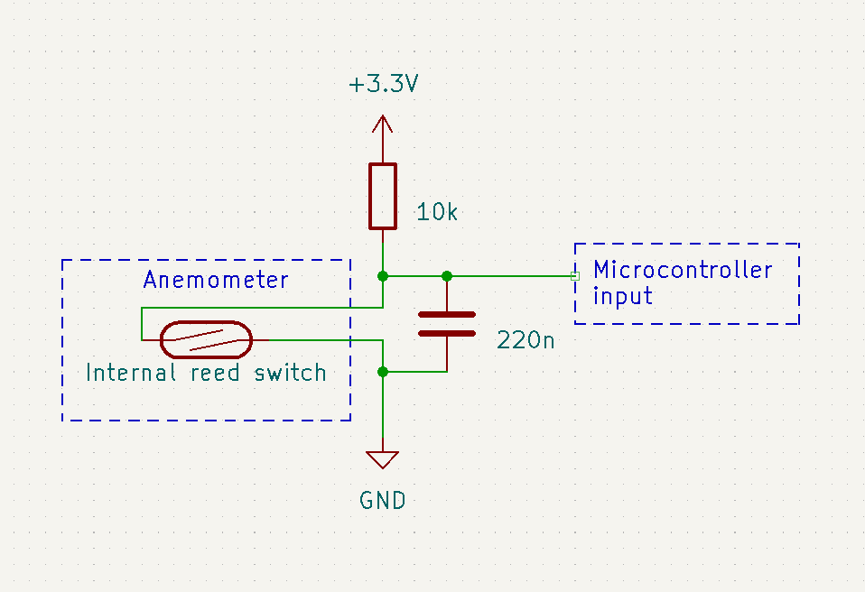

Figure 3‑8. Anemometer reading circuit

## Wind Vane

Reading the wind direction using the wind vane is essentially measuring the resistance from the internal circuit (Figure 2‑6a) via pins 2 and 5 of the device’s RJ11 cable. As mentioned in section 2.2.2, this could not be done directly, but through signals generated with a current mirror circuit. Since the highest measurable resistance value from the wind vane is 119.60 kΩ, and the maximum ADC input for the microcontroller is 3.3 V, the current fed to the sensor must not exceed $\frac{3.3 V}{119.60 kΩ}=27.59 μA$. On the other hand, the lower the current, the narrower the voltage gap among some wind directions (e.g., East-Northeast and East-Southeast directions), thus a difficulty in precisely distinguishing. Hence, assume the current mirror in Figure 2‑7a produces a constant current of 27.59 µA, the input signals for the microcontroller’s ADC module are consequently $3.3 V-27.59 μA×R$.

|  |  |  |  |  |  |
| --- | --- | --- | --- | --- | --- |
| Direction | $$R_{WindVane}$$ | $$v_{ADC_input}$$ | Direction | $$R_{WindVane}$$ | $$v_{ADC_ipnut}$$ |
| North | 33.10 KΩ | 2.3868 V | North-Northeast | 6.56 KΩ | 3.1190 V |
| Northeast | 8.19 KΩ | 3.0740 V | East-Northeast | 892 Ω | 3.2754 V |
| East | 1.002 KΩ | 3.2724 V | East-Southeast | 688 Ω | 3.2810 V |
| Southeast | 2.19 KΩ | 3.2396 V | South-Southeast | 1.40 KΩ | 3.2614 V |
| South | 3.88 KΩ | 3.1930 V | South-Southwest | 3.12 KΩ | 3.2139 V |
| Southwest | 15.98 KΩ | 2.8591 V | West-Southwest | 14.10 KΩ | 2.9110 V |
| West | 119.60 KΩ | 236 µV | West-Northwest | 42.07 KΩ | 2.1393 V |
| Northwest | 64.90 KΩ | 1.4266 V | North-Northwest | 21.90 KΩ | 2.6958 V |

Table 5. Wind vane ADC input signals by current mirror with $I_{0}=27.59 μA$

It could be derived from Table 5 that the minimum voltage step to be detected by the ADC module is 3 mV between the East and the East-Northeast directions. Moreover, most calculated values are close to 3.3 V, which makes it more difficult to recognise the real wind direction picked up by the wind vane while the system operates autonomously. One major problem is the noise, which has been observed to be up to 29 mV, causing the supposed ADC input signals of the wind directions to fluctuate randomly and overlap each other. Therefore, an alternative usage of a voltage divider is investigated for hardware interfacing with the wind vane.

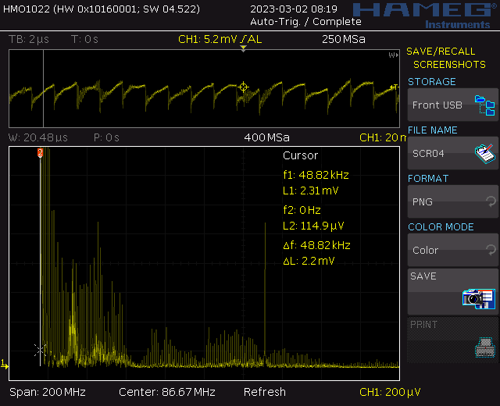

Figure 3‑9. A noise instance captured during a test on the wind vane

Unlike the current mirror, the voltage divider as shown in Figure 2‑7b works directly with voltage signals. The voltage level of an ADC input signal is calculated by $v_{ADC_input}=3.3 V ×\frac{R_{WindVane}}{R_{external} + R_{WindVane}}$. It is found that for $R_{external}$ being from 510 Ω to 47 kΩ, the value of either 3.3 kΩ or 3.9 kΩ produces the widest minimum voltage difference among the signals corresponding to the wind directions. Since a 3.3-kΩ resistor is available when the interfacing circuit for wind vane is designed, that value is chosen for $R_{external}$.

|  |  |  |  |  |  |
| --- | --- | --- | --- | --- | --- |
| Direction | $$R_{WindVane}$$ | $$v_{ADC_input}$$ | Direction | $$R_{WindVane}$$ | $$v_{ADC_input}$$ |
| North | 33.10 KΩ | 3.0008 V | North-Northeast | 6.56 KΩ | 2.1955 V |
| Northeast | 8.19 KΩ | 2.3522 V | East-Northeast | 892 Ω | 0.7022 V |
| East | 1.002 KΩ | 0.7686 V | East-Southeast | 688 Ω | 0.5693 V |
| Southeast | 2.19 KΩ | 1.3164 V | South-Southeast | 1.40 KΩ | 0.9830 V |
| South | 3.88 KΩ | 1.7833 V | South-Southwest | 3.12 KΩ | 1.6037 V |
| Southwest | 15.98 KΩ | 2.7352 V | West-Southwest | 14.10 KΩ | 2.6741 V |
| West | 119.60 KΩ | 3.2114 V | West-Northwest | 42.07 KΩ | 3.0600 V |
| Northwest | 64.90 KΩ | 3.1403 V | North-Northwest | 21.90 KΩ | 2.8679 V |

Table 6. Wind vane ADC input signals by voltage divider with $R_{external}=3.3 kΩ$

It could be observed that the values of $v_{ADC_input}$ by the voltage divider are distributed more evenly over the full 3.3-V input range of the ADC module. The narrowest voltage gap to distinguish among the values has increased to 59.2 mV (between North and West-Northwest wind directions), thus the reduced tension in wind direction recognition. However, the noise issue remains unaccounted for. The solution for this has been introduced in section 2.4.2, an analogue LPF.

Two factors to be taken into account upon integrating a LPF are the cut-off frequency and the current allowance through the filter. The latter is limited by the resistor of a LPF as $\frac{v_{voltage divider}}{R_{filter}}$, which should be in the range of 1 µA to 5 mA for the STM32F103C8T6 microcontroller [9]. The former depends on the noise signals and the highest direction switching frequency of wind directions, both of which are indeterminable.

The lowest noise frequency observed during the test of Figure 3‑8 is 12.62 kHz, and electrical noise may go down to 7 kHz [55]. The cut-off frequency for the LPF is then chosen to be a common value of 1 kHz. From the list of available values on the market, the resistor is picked as 680 Ω, by which the input current is between 837.21 µA (by the East-Southeast direction) and 4.72 mA (by the West direction) and stays within the allowed range for the protection of the microcontroller. By applying the function of LPF cut-off frequency $f_{c}=\frac{1}{2πRC}$, the capacitance is expected to be 234.05 nF. However, since a such value does not exist, multiple capacitors could be connected in parallel to produce the closest one, starting with the highest available value below 234.05 nF. After 3 capacitors of 220 nF, 10 nF, and 1 nF are picked, the cut-off frequency is recalculated to be $f_{c}=\frac{1}{2π × \left(680 Ω\right) × (220 nF+10 nF+1 nF)}=1.013 kHz$. Finally, a simulation is performed to obtain the responses of the filter.

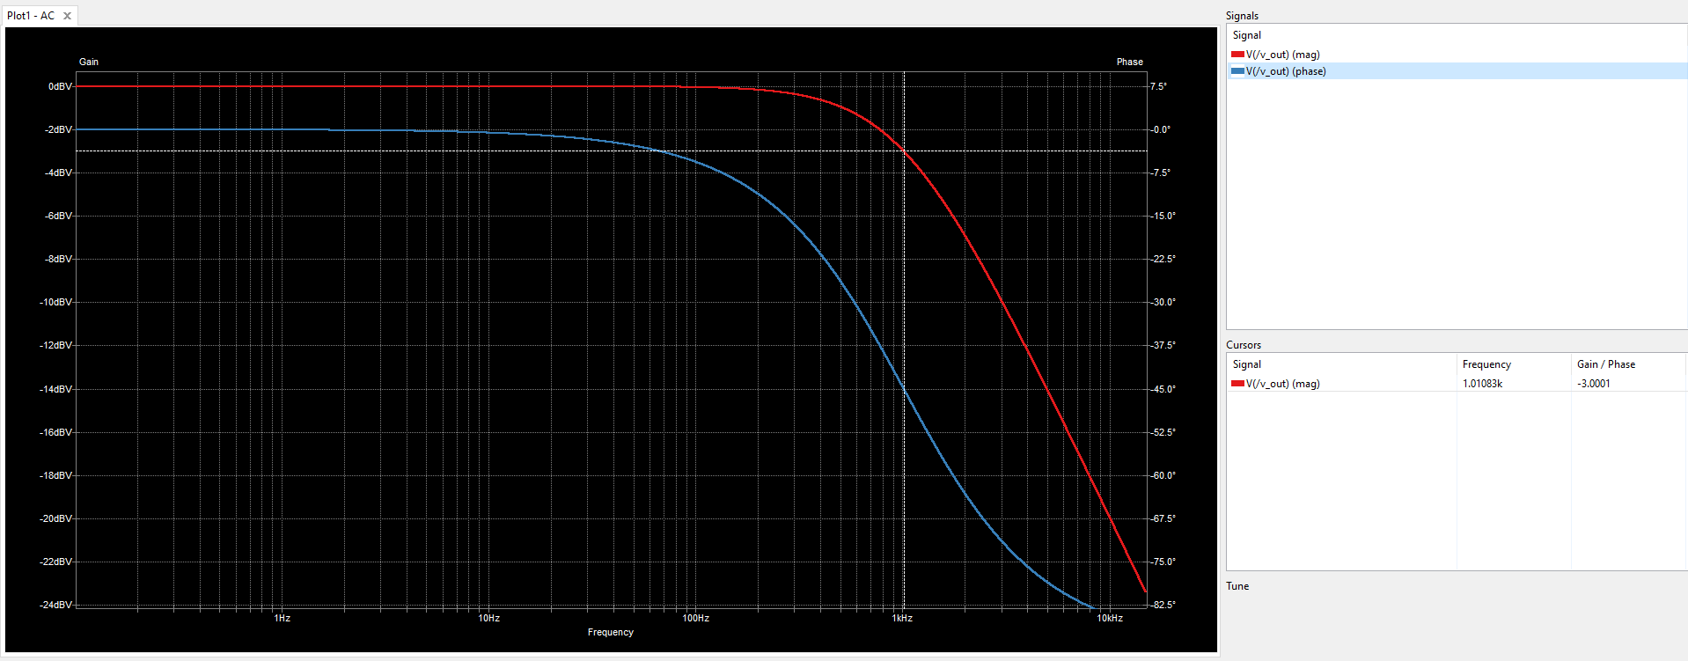

Figure 3‑10. Frequency response of the 1.013-kHz RC LPF

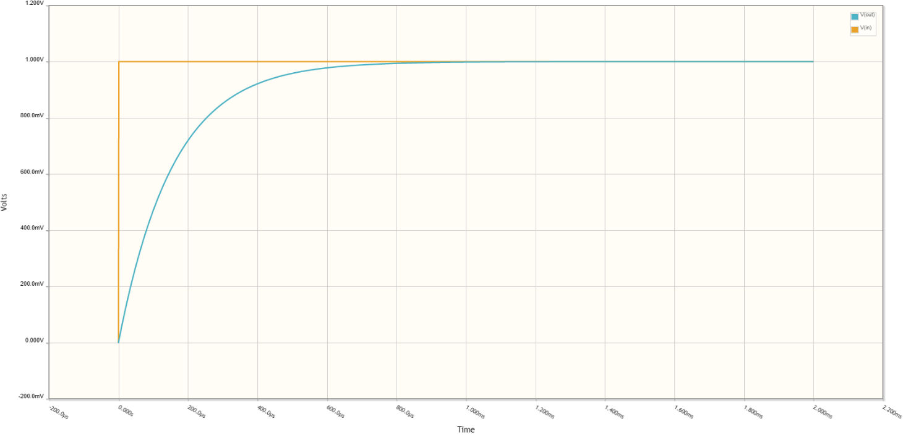

Figure 3‑11. Step response of the 1.013-kHz RC LPF

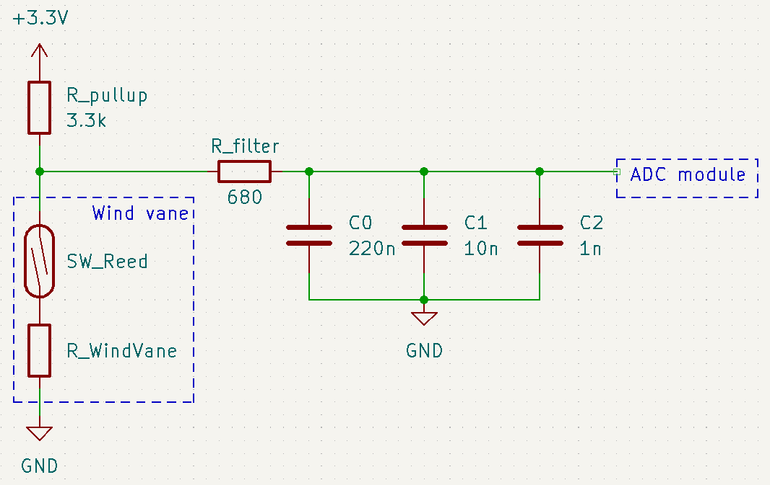

Figure 3‑12. Circuitry for reading the wind vane

## Rain Gauge

As mentioned in section 3.2, there is usually a problem with noise because of the mechanical reed switch. Since the rain gauge is essentially the same as the anemometer in terms of electronics, the circuitry for the anemometer which includes a decoupling capacitor could be applied for the rain gauge. However, should the external pullup resistor be removed to reduce the number of on-board components, the input pullup function of the microcontroller could be utilised instead. Therefore, the circuitry of Figure 3‑12b is used in this design.

|  |  |
| --- | --- |
|  |  |
| 1. Using an external pullup resistor | 1. Using the microcontroller’s input pullup |

Figure 3‑13. Circuitry for interfacing with the rain gauge

## BME280

As mentioned in section 2.2.4, communication with the BME280 sensor could be done via either SPI or I2C protocols. In this design, both the SPI ports of the microcontroller have been reserved for other modules, the I2C protocol is utilised for BME280.

In I2C mode, the CSB pin must stay “HIGH” by VDDIO, while the SDO pin is used to choose the address of the BME280 on the bus [19]. There are only 2 potential I2C addresses for BME280, 0x76 and 0x77, correspondingly to the signals “LOW” and “HIGH” on the SDO pin. Moreover, it is recommended that the logic levels on these 2 pins are directly from GND and VDDIO, not from a digital output of the microcontroller, so the circuitry for the BME280 in I2C mode is as depicted in Figure 3‑13. In this design, both the VDD and VDDIO signals are tied to the supply voltage level +3.3 V, the separation of notations is unnecessary; the default I2C address for BME280 as shown in Figure 3‑13a is used.

|  |  |
| --- | --- |
|  |  |
| 1. Default I2C address: 0x76 | 1. I2C address: 0x77 |

Figure 3‑14. BME280 setup for the I2C protocol

## DS18B20

In section 2.2.5, it is briefly demonstrated that the DS18B20 has 2 modes of operation, but it has to be predetermined in a specific design. Although the parasite mode reduces the total power consumption, it may prompt errors in producing software since maintaining power for the parasitic device has to be taken into account and is easily missed. Moreover, inadequacy in doing so has been found to still allow a DS18B20 to produce outputs, but the data is faulty in some cases. In Figure 3‑14, the aftermath of the aforementioned inadequacy is captured on a 1-Wire bus. In the following 3 figures of fault instances, the first DS18B20 is parasitically powered via the digital pin for 1-Wire bus of the microcontroller, while the other 2 DS18B20s in parasite mode have their MOSFET 1 and MOSFET 2 turned on, respectively, before and after the microcontroller releases the 1-Wire bus.

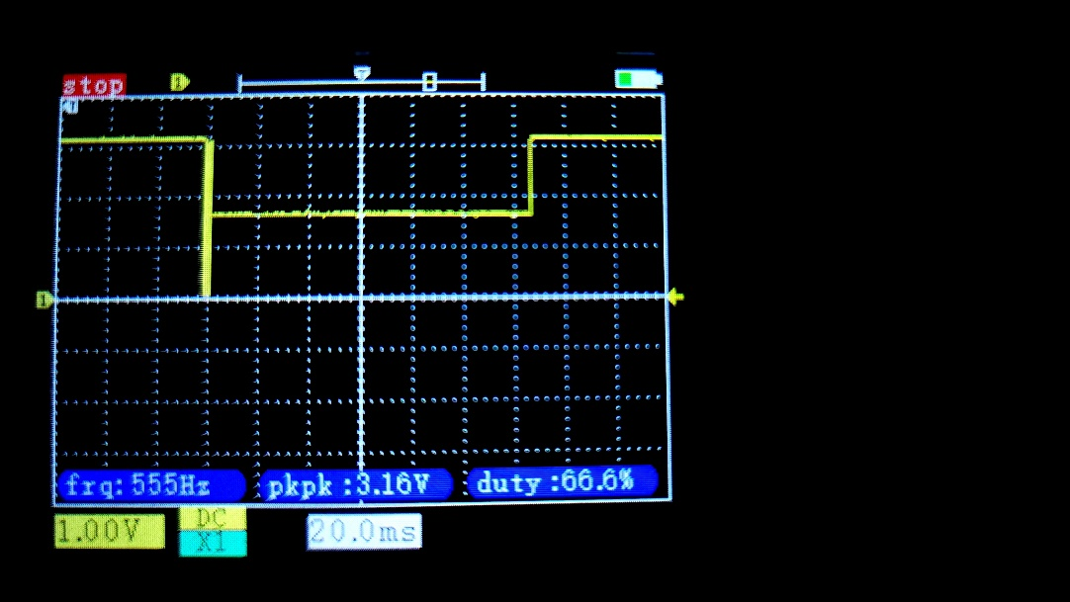

Figure 3‑15. Insufficient power for DS18B20 in parasite mode due to voltage drop   
when master turns on MOSFET after releasing the 1-Wire bus

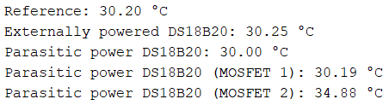

Figure 3‑16. Faulty data by only DS18B20 with MOSFET 2

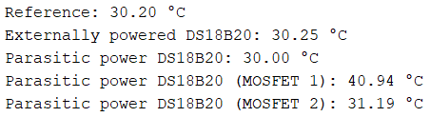

Figure 3‑17. Inconsistency of data output by DS18B20 with MOSFET 1 as compared to Figure 3‑15

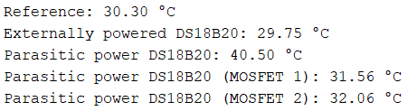

Figure 3‑18. A defective result yielded due to software error for the first DS18B20 in parasite mode

It could be observed from the figures above that the externally powered DS18B20 produces temperature data stably compared to the DS18B20s in parasite mode. Therefore, in this design, the circuitry chosen for interfacing with the DS18B20 temperature sensor is depicted by Figure 2‑14a.

## SX1278

Since this design makes use of SX1278 pinout module, further circuitries are not necessary to establish hardware connections. On the design of the Autonomous Wireless Agrometeorology Station, all the communication and control pins of the LoRa module could be connected directly to the corresponding pins of the STM32F103C8T6 microcontroller because of the similar 3.3-V logic level. If the microcontroller and the LoRa module share a voltage regulator as power source, there may be occasions when the latter puts stress on the regulator by drawing too much current during a transmission, resulting in unexpected behaviours like sudden voltage drops and undesired resets, or even damages to other components and devices. In order to prevent such issues, a separate voltage regulator is setup for the SX1278 LoRa module.

Apart from the SPI connections, the SX1278 LoRa module requires 2 more pins from the microcontroller for interrupts and resets. The interrupt pin is controlled by the module to inform the microcontroller of incoming data communication, while the LoRa_Reset signal line is required and controlled by software. The hardware connections are the same between the server side and the sensor station.

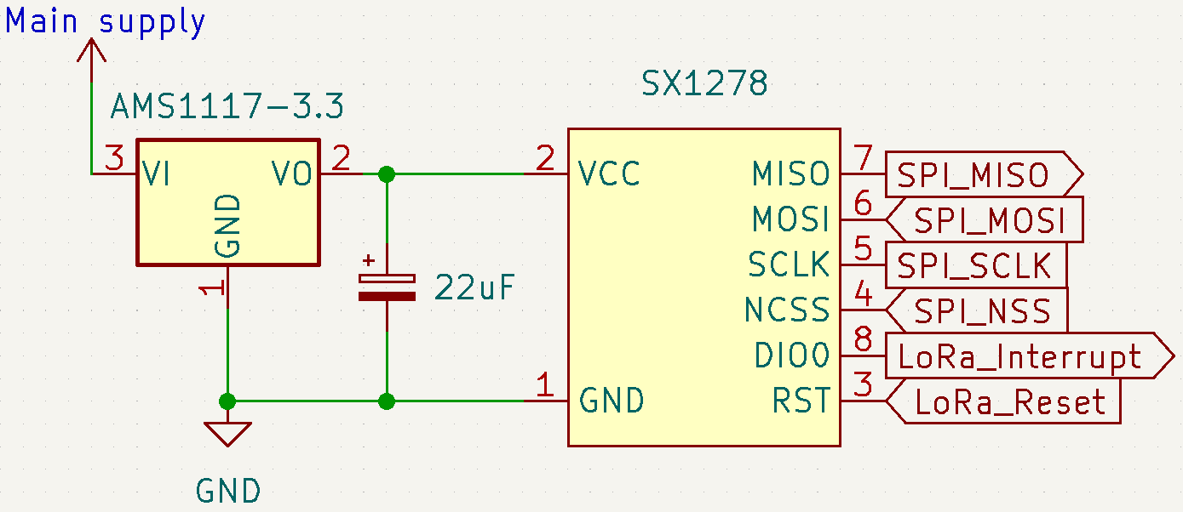

Figure 3‑19. Hardware setup for SX1278 LoRa module

## DS3231SN

Since the DS3231SN pinout module contains all the necessary components for the RTC IC, there is no need for further circuitries. It does not matter whether the DS3231SN is powered at 3.3 V or 5 V, since the I2C pins of the STM32F103C8T6 microcontroller are 5-V tolerant [9]. However, if the RTC module is powered at 5 V, the minimum logic “HIGH” input is $0.7×\left(5 V\right)=3.5 V$, which is higher than the logic level of the microcontroller. Furthermore, sharing the I2C bus is another device with the maximum input/output voltage of 3.6 V, the BME280 sensor [19], 5-V power supply is not ideal for integrating the DS3231SN with the system. Therefore, the RTC module is to be powered at 3.3 V, and the backup battery is chosen to be a non-rechargeable CR2032. The removal of either the 1N4148 or the 200-Ω resistor is not necessary in this setup since the difference between power supply and the battery voltage $\left|3.3 V-3 V\right|=0.3 V$ is not enough for the diode to conduct and damage the battery.

Since some other modules work with the alarms from the DS3231SN, which is further investigated in section 4, the SQW of the RTC module is connected to an interrupt input of the microcontroller under a signal named $RTC_Alarm$.

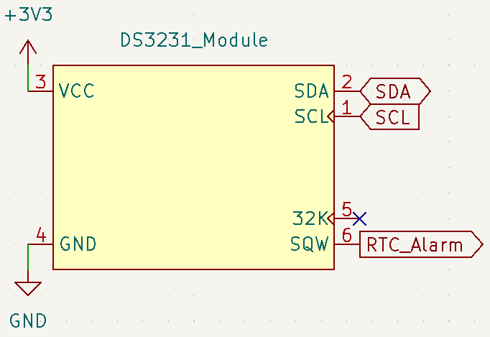

Figure 3‑20. Hardware setup with the DS3231SN RTC module

## System Powering

In theory, powering a system from 2 sources simultaneously is possible if the sources are independent and produce similar voltage outputs. However, in this off-grid system, the battery unit is dependent on the photovoltaic cells to be charged. Therefore, the main system can be powered by either the solar panel or the batteries at a time.

An ideal circuit of the powering unit for the sensor station should be able to switch the sources without introducing any downtime to the sensor station. The block diagram of a such circuit is as follows.

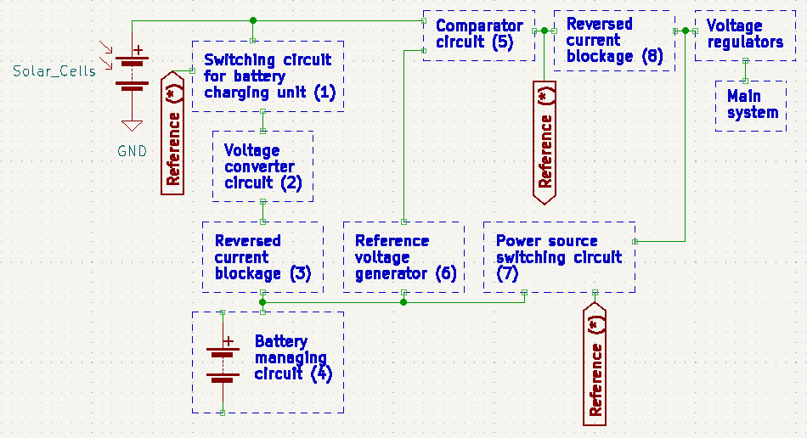

Figure 3‑21. Block diagram of the system powering circuitry

The expected operations of the circuit are divided into 3 phases:

* The solar panel charges the batteries and powers the main system simultaneously when it produces a voltage above the charging voltage of the batteries.
* The solar panel only powers the main system when it produces a voltage above the minimum input voltage of the voltage regulators, but below the charging voltage of the batteries.
* The solar panel is electrically disconnected when it outputs a voltage below the minimum input for the voltage regulators; the batteries take over the line and powers the main system instead.

The Reference (*) is the voltage of the solar panel injected into blocks (1) and (7). In the first phase, Reference (*) enables block (1), allowing a current flow into block (4) to charge the batteries. At the same time, Reference (*) disables block (7) whose function is to create a bridge for the battery current in a later phase. In this phase, block (6), Reference voltage generator, has the input of solar panel through blocks (1), (2), and (3), and produces a voltage reference to the comparator circuit (5); the reference by block (6), however, is lower than the direct input of the solar panel to block (5) which results in current continuing to flow from the solar panel to the main system. A side note is that block (6) must always generate a voltage equal to the minimum input voltage of the voltage regulators.

In the second phase, despite the Reference (*) enables block (1) for a current flow, block (2), Voltage converter circuit, expectedly outputs 0 V due to insufficient input voltage from the solar panel. As a result, the current from the solar panel only flows on 1 path and no longer flows toward block (4). Block (6) now has the input from the batteries, but its reference for block (5) remains lower than the solar panel voltage, so the path from the solar panel to the main system persists. In this phase, block (3) prevents the reversed current flow from the batteries to the voltage converter circuit (2), thus protection against any potential damages.

In the third phase, the reference by block (6) is greater than the input voltage of the solar panel to block (5), so block (5) disrupts the path from the solar panel to the main system. Expectedly, Reference (*) drops to 0 V and disables block (5), which makes the solar panel totally isolated. As opposed to the first phase, block (7) is enabled due to the absence of Reference (*) voltage and provides a current path from the batteries to the voltage regulators and the main system. In this phase, block (8) prevents Reference (*) from having the voltage of the batteries to mimic its behaviours in the first and second phases.

Since this remains a concept, no circuitry has been built and tested. In order to realise the idea, the components need picking and studying carefully, due the sensitive nature of voltage comparison in the concept. For the time being, 4 things that are clear are:

* The main system is expected to run at 3.3 V, so the voltage regulators should have the input of at least 3.6 V for some components. In case of AMS1117-3.3, the typical input is 3.3 V + 1.1 V = 4.4 V [56]. This voltage needs to be the output of block (6), Reference voltage generator.
* The “Reversed current blockage” blocks (3) and (8) have to have low forward voltage drops as well as low reversed leakage currents for the maximum protection of other components/blocks.
* The concept works in 3 phases if the solar panel has the maximum voltage output higher than the charging voltage of the batteries. In turn, block (2), Voltage converter circuit, is essentially a buck converter.
* The switching circuits of blocks (1) and (7) need to be fast so as not to introduce any downtime to the main sensor station. Electrolytic capacitors shall be needed to compensate for the temporary power drop during switching periods.

# Software design

## Anemometer

In [57], Kristensen states that “if it takes the time $∆t$ for the cup rotor to complete one full revolution, the average wind speed in this period is $2πl/∆t$”, where $l$ is “the length of the column of air which has to pass through the anemometer for the cup rotor to turn one radian”. Furthermore, in order to minimise the error introduced by wind gusts, the wind speed is to be measured over a fixed duration $T$ (e.g., 5 minutes) [58], thus $N$ revolutions of the rotor and the estimated result becoming $N × {2πl}/T$ [57]. However, as demonstrated in [59], upon integrated with a microcontroller, the anemometer could return the wind speed as $N×{2πR}/T$, where $R$ is the radius from the pivot to the edge of a cup. Since it is determined that the anemometer produces 2 pulses per revolution, the number of pulses $n$ could be counted over a period $T$ for a simple solution of $\frac{n}{2} ×{2πR}/T$ for average wind speed.

Since reading from the anemometer is reading the pulses produced by the operation of the reed switch, the software is interrupt-based. Following [58], the fixed sampling duration is chosen to be 5 minutes. A routine for reading the wind speed from the anemometer is initialised as follows.

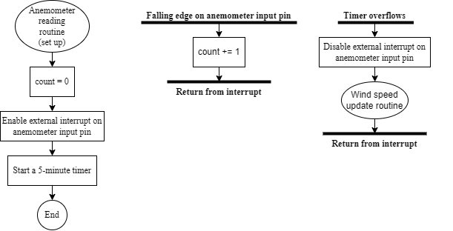

Figure 4‑1. Initialisation of an anemometer reading routine

In $Wind speed update routine$, the wind speed is calculated by replacing the parameter $n$ with the value of $count$. The measured parameter $R$ is 9.2 cm (Figure 2‑3b), and $T$ is 5 minutes. In order to obtain the wind speed in metres per second (m/s), the fixed parameters are applied as 0.092 m and 300 s. For example, if $count$ is recorded to be 2000, the supposed wind speed is $\frac{2000}{2}×\frac{2π×(0.092 m)}{300 s}=1.93 m/s$, or 6.94 km/h

## Wind Vane

In order to determine the wind direction from the wind vane, the ADC module of the microcontroller is to be used. The analogue input signal is sampled, then converted from raw data to voltage value by $v_{ADC_input}=(3.3 V) ×\frac{Raw ADC value}{2^{12}-1}$. Since signal from the voltage divider is essentially a step signal, the filtered input at the ADC module should remain the $v_{ADC_input}$ from Table 6. By applying the formula for voltage divider output $v_{ADC_input}=(3.3 V) ×\frac{R_{WindVane}}{\left(3.3 kΩ\right)+ R_{WindVane}}$, the resistance $R_{WindVane}$ from the wind vane is calculated as $R_{WindVane}=\left(3.3 kΩ\right)×\frac{v_{ADC_input}}{\left(3.3 V\right) - v_{ADC_input}}$.

Although the resistance value from the wind vane is obtained, comparison it with the given values in Table 1 and Table 6 for wind direction is not possible, since a real system never produces the exact numbers. Instead, by collating the difference between the read $R_{WindVane}$ and each resistance entry in Table 1 could the wind direction be assumed. The resistance value from the table closest to the read $R_{WindVane}$ should yield the wind direction picked up by the anemometer.

## Rain Gauge

Like the anemometer, monitoring precipitation using the rain gauge is done by counting the pulses produced by the device over a fixed period of time. According to [60], the typical durations could be 24, 48, 72 hours, or longer, depending on the sites of observation. In this design, the rainfall data is recorded daily at 9 am. In order to reduce the microcontroller resource usage, the daily alarm is set by the DS3231 module. An interrupt for rising edges is attached to a microcontroller’s interrupt pin connected to the alarm pin of the real-time clock module; whenever an edge occurs, the microcontroller updates the precipitation data of rainfall, and resets the $count$ variable, as well as the alarm. Since the buckets tip once per 0.3 mm of rainfall, the rain amount in millimetres of the previous day is the multiple by $count$ of 0.3 mm.

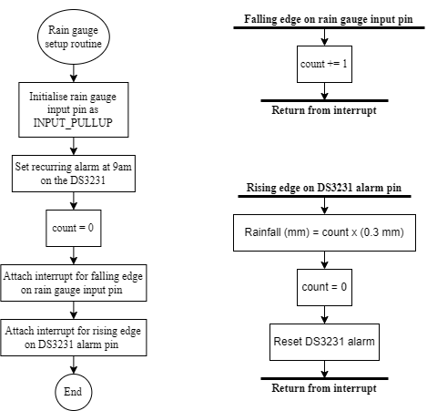

Figure 4‑2. Software setup and data acquisition for the rain gauge

## BME280

Since this design is tested under the Arduino framework, all communications with the BME280 are done using the Arduino library “Adafruit_BME280_Library” by Ladyada [61].

During the software setup scope, after the BME280 has been initialised (e.g., as $bme280$), the sensor parameters could be configured following Table 2 by the $setSampling()$ method, for example:

*bme280.setSampling (  
 Adafruit_BME280::MODE_FORCED, // Forced mode  
 Adafruit_BME280::SAMPLING_X1, // Temperature sampling rate x1  
 Adafruit_BME280::SAMPLING_X2, // Pressure sampling rate x2  
 Adafruit_BME280::SAMPLING_NONE, // Humidity sampling is turned off  
 Adafruit_BME280::FILTER_X4, // IIR filter coefficient = 4  
 Adafruit_BME280::STANDBY_MS_10 // Standby duration for normal mode is 10 ms  
 );*

If the BME280 is not set in normal mode, the last parameter could be omitted.

During system runtime, the values for temperature (in ℃), pressure (in hPa), and humidity (in %RH) could be issued and saved as follows:

*temperature = bme280.readTemperature();*

*pressure = bme280.readPressure() / 100.0F;*

*humidity = bme280.readHumidity();*

If the BME280 is set in forced mode, the sensor enters sleep mode after every measurement. Before new environmental parameters are requested by the microcontroller, the sensor must wake up and perform a new sampling routine. This could be done with a single $takeForcedMeasurement()$ method:

*bme280.takeForcedMeasurement();*

Moreover, in case the sensor configurations are to be changed during runtime, the $setSampling()$ method could always be called with updated values.

## DS18B20

Although implementing the 1-Wire protocol manually only requires digital input/output operations and timing, in order to avoid excessive coding, the Arduino library “OneWire” by Paul Stoffregen is used [62]. One routine for reading a DS18B20 is as follows:

1. Declaration of a OneWire instance.
2. Perform a communication initialization by a reset pulse, followed by a “Skip ROM” command (0x33).
3. Request a temperature conversion by writing the “Convert T” command (0x44), then halt for 750 ms.
4. Perform a 1-Wire bus reset for a new command sequence, followed by another “Skip ROM” command.
5. Request to read the scratchpad of the DS18B20 with the “Read scratchpad” command (0xBE)
6. Read the exact first 2 bytes of the DS18B20’s scratchpad, or 5 bytes if the thermometer resolution is unknown.
7. Calculate the temperature result in degree Celsius from the read bytes, and convert the temperature to other units if necessary.

Since the design includes only 1 DS18B20 sensor to measure the temperature at ground level, the software utilises the “Skip ROM” command in steps 2 and 4 to reduce the communication load on the 1-Wire bus. A delay of 750 ms in step 3 is announced to the maximum conversion time of a DS18B20 [24], although it is found to be thermometer resolution-dependent as shown in Figure 4‑3. Instead of a delay, thanks to the external power on the VDD pin of the DS18B20, a read request could be sent continuously at the end of step 4 until a data of 0x01 is transmitted by the sensor; step 4 then takes place.

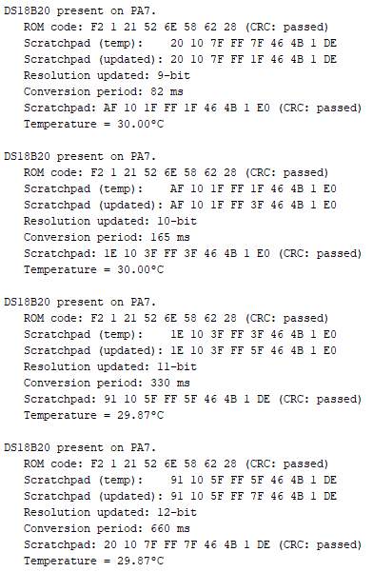

Figure 4‑3. Temperature conversion time by thermometer resolution

A one-time setup routine could be performed when the system with DS18B20 is powered for the first time or at every reset in order to configure the thermometer resolution for the sensor:

1. Declaration of a OneWire instance.
2. Perform the communication initialization by a reset pulse, followed by a “Skip ROM” command.
3. Request to read the scratchpad of the DS18B20 with the “Read scratchpad” command if the sensor’s existing temperature thresholds for alarms are to be kept.
4. Read the first 5 bytes of DS18B20’s scratchpad, then discard the first 2 bytes.
5. For the remaining 3 bytes, modify the first 2 if the temperature thresholds for alarms are subject to be changed. The last one is updated accordingly to the desired thermometer resolution:
   * + 9-bit for 0.5 ℃ resolution: 0x1F
     + 10-bit for 0.25 ℃ resolution: 0x3F
     + 11-bit for 0.125 ℃ resolution: 0x5F
     + 12-bit for 0.0625 ℃ resolution: 0x7F
6. Perform a 1-Wire bus reset for a new command sequence, followed by another “Skip ROM” command.
7. Send a “Write Scratchpad” command (0x4E), followed by the 3 updated bytes from step 5 in the exact order read in step 4; otherwise, data corruption may occur and render the sensor incapacitated.
8. Perform another 1-Wire bus reset for a new command sequence, followed by a “Skip ROM” command, then a “Copy Scratchpad” command (0x48) and a 10-ms delay. This step is optional, but it allows the new settings for the sensor to retain even after the system undergoes a power loss.

The advantages of performing a setup routine for DS18B20 are that only 2 bytes are needed in step 6 of the data reading routine since the thermometer resolution is known beforehand, and that the resolution of the temperature data and the conversion time are predetermined. Once the thermometer resolution information is available, either via setup or reading routine, a conversion of sensor data to temperature value could be done. The raw data should be a signed 16-bit integer where the most significant (MS) byte and the least significant (LS) byte are byte 1 and byte 0 read from the sensor’s scratchpad, respectively. Based on the thermometer resolution of the DS18B20, the number of LS bits of the raw data is cleared (set to ‘0’) as follows:

|  |  |
| --- | --- |
| Thermometer resolution | Number of LS bits to be cleared |
| 9-bit | 3 |
| 10-bit | 2 |
| 11-bit | 1 |
| 12-bit | 0 |

Table 7. Quantity of ineffective LS bits by DS18B20’s thermometer resolution

Afterwards, the 16-bit raw data becomes the true “16-bit sign-extended two’s complement” of the temperature in degree Celsius [24]. That temperature value could simply be calculated by

$$Temperature \left(℃\right)= \frac{Raw data}{16}$$

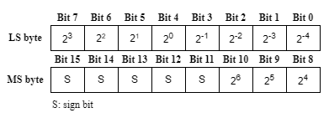

Figure 4‑4. Bit format of the raw temperature value [24]

## SX1278

LoRa and LoRaWAN are 2 separate concepts. LoRa refers to the technology of wireless modulation, thus the physical layer of the LoRa Network [63]. LoRaWAN, on the other hand, is a set of protocols developed on top of the LoRa physical layer, also known as the Media Access Control (MAC) layer [63]–[65]. An SX1278 module allows a system to join a LoRa network as a node for transmission of data; however, data exchange could only be done between a node and a gateway as illustrated in [36], [65] because of the star topology by LoRaWAN [63], [66].

In this design, 2 SX1278 modules are supposed to establish communications between the sensor station and a server. Without a LoRa gateway, a such task is unachievable. However, a workaround could be done by mimicking some behaviours of a LoRa gateway at the server side by software.

The software is built on the Arduino library “arduino-LoRa” by Sandeep Mistry. At the initialisation step, the LoRa frequency band on which communication is established must be chosen. Not all the frequency bands of LoRa are available to use due to the Regional Parameters of LoRaWAN [67]. According to [68], [69], the frequency plan in Vietnam is AS923-925 (“AS2”), which ranges from 923.2 MHz to 924.8 MHz [70] and is to be avoided since permission to use is not available. [65] states that the 433 MHz frequency band could be used without a license in Vietnam, so it is put in software setup at both the server side and the sensor station.

After choosing the LoRa frequency, within the software, 3 functions are to be defined. The first one is a function which handles data transmissions requested by software during runtime. The second function is an interrupt service routine (ISR) that puts the LoRa module in receive mode upon completion of a transmission. Lastly, another ISR handles reading the message byte by byte when the SX1278 module detects an incoming transmission. In order to for the Arduino library to work, the 3 functions are assigned to the virtual methods of the library itself within the setup routine.

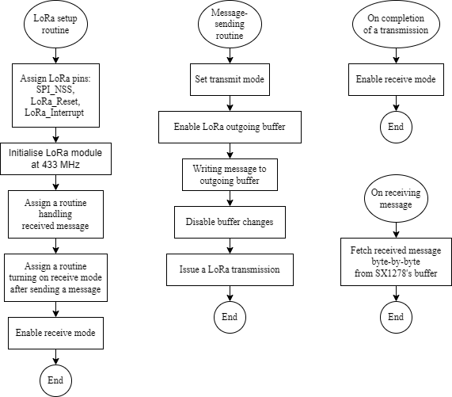

Figure 4‑5. SX1278 software setup and message-handling routines

The only difference between the software for SX1278 on the sensor station and that at the server side is the mode setup functions. Since the SX1278 allows setting LoRa I and Q signals [44], a one-on-one communication could be established between 2 modules as a node and a “fake” gateway as follows:

|  |  |  |
| --- | --- | --- |
| Function | Gateway | Node |
| Set transmit mode | Inverted LoRa I and Q signals | Normal LoRa I and Q signals |
| Set receive mode | Normal LoRa I and Q signals | Inverted LoRa I and Q signals |

Table 8. LoRa I and Q signals for a gateway and a node [71]

## DS3231SN

The DS3231SN could be controlled via the use of the Arduino library “DS3231” in [72]. If an instance of the $DS3231$ class is declared as $myRTC$, the date and time data is accessed as follows:

*DateTime now = myRTC.now();* // Compulsory for data readout *Date = now.day();* // Day of month field (from 1 to 31) *Month = now.month();* // Month field (from 1 to 12) *Year = now. year();* // Year field (from 2000 to 2100 by the library) *Hour = now.hour();* // Hour field (from 0 to 23 for 24-hour format; or 1 to 12) *Minute = now.minute();* // Minute field (from 0 to 59) *Second = now.second();* // Second field (from 0 to 59)

On the other hand, if the RTC is to be updated, the data must first be converted to the binary-coded decimal format and then written to the DS3231SN as follows:

*myRTC.setYear(Year_data % 100);* // Updated year data *myRTC.setMonth(Month_data);* // Updated month data *myRTC.setDate(Date_data);* // Updated day of month data *myRTC.setClockMode(false);* // 24-hour time format; *true* in case of 12-hour format *myRTC.setHour(Hour_data);* // Updated hour data *myRTC.setMinute(Minute_data);* // Updated minute data *myRTC.setSecond(Second_data);* // Updated second data

Although the DS3231SN could maintain the calendar from 1970 to 2100 [47], the software deals with only the years from 2000 to keep it simple. Each field could be done separately, so there is no need to update or read from the whole calendar and clock at once.

In section 4.3, it is mentioned that a daily alarm at 9 am is used to mark an update of rainfall data. The DS3231SN has 2 built in alarms, Alarm 1 and Alarm 2. The only difference between the two is that Alarm 2 does not check for matching seconds. Alarm 1 is utilised in this design and the 9 am daily alarm for the rain gauge is set up by calling:

*myRTC.setA1Time(1, 9, 0, 0, 0x8, false, false, false);*

*myRTC.turnOnAlarm(1);*

*myRTC.checkIfAlarm(1);*

Whenever an interrupt caused by the rising edge on the $\overline{INT}/SQW$ pin of the RTC module occurs, $myRTC.checkIfAlarm(1);$ line must always be called to make sure the interrupt has been caused by Alarm 1, and to clear the alarm flag for a new daily cycle.

## Server

In this design, the server contains only a nodeMCU ESP8266 connected to a SX1278 LoRa module via I2C and the online database InfluxDB via a home Wi-Fi network.

In the setup step, the nodeMCU configures the software for SX1278 following Section 4.6 as a “fake” gateway. The network credentials and InfluxDB APIs must also be ready beforehand to establish a connection to the cloud. On the web interface of InfluxDB, a bucket must have been created beforehand; a dashboard is then set up to provide visual elements of the sensor readings nodeMCU receives. Ideally, the nodeMCU receives a set of sensor readings every 5 minutes and uploads to the database immediately.

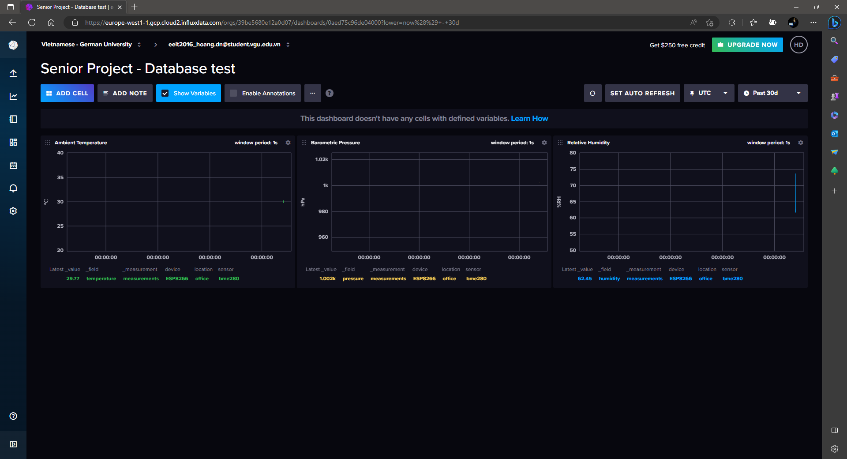

Figure 4‑6. Example of a dashboard providing visual element of sensor readings in InfluxDB

# Experimental Characterisation

For this conceptual design, only the unit tests of some modules are performed due to the limitation of testing conditions. The tests are done for the wind vane, the rain gauge, temperature sensing units of DS18B20 and BME280, humidity sensing units of BME280, the SX1278 LoRa modules, and the InfluxDB online database. Wind speed-reading with the anemometer cannot be tested for the time being due to the lack of a reference for data verification, which is also the same case for the pressure sensing unit of BME280. The accuracy test of the DS3231 RTC requires the module to be run over a long period (e.g., 5 months [46]) while this senior project lasts 4 weeks, thus its unavailability. The tests on the rain gauge and SX1278 LoRa modules have been attempted, but are excluded from this report due to inadequate testing conditions for proper results.

## Wind Vane

The wind vane is a self-referenced device, thanks to the 4 direction indicators on its body. However, in this test, the true directions are not to be read; instead, the indicators only help to determine the expected resistance readout values and the corresponding voltage signals from Table 1 and Table 6. The angle of the rudder blade, in turn, is set manually by a step of approximately 22.5˚, starting at North, in the clockwise direction. Simultaneously, a multimeter is used to measure the voltage output at the voltage divider side (Figure 3‑11) to make sure no step is skipped by human errors. When the voltage displayed on the multimeter is stable, the corresponding Azimuth degree of a direction in Table 1 is input to the microcontroller via Serial Monitor. The microcontroller then samples 20 values per input direction entry, calculates the voltage and the resistance, as well as the direction for each value. The test is done twice, once on a wind vane circuit with a LPF following Figure 3‑11, then the circuit without the filter. All the data collected and processed by the microcontroller, including the expected directions, raw ADC values, calculated voltage, calculated resistance, and resulted wind directions, is saved in a comma-separated values (CSV) file on a microSD card to be accessed later.

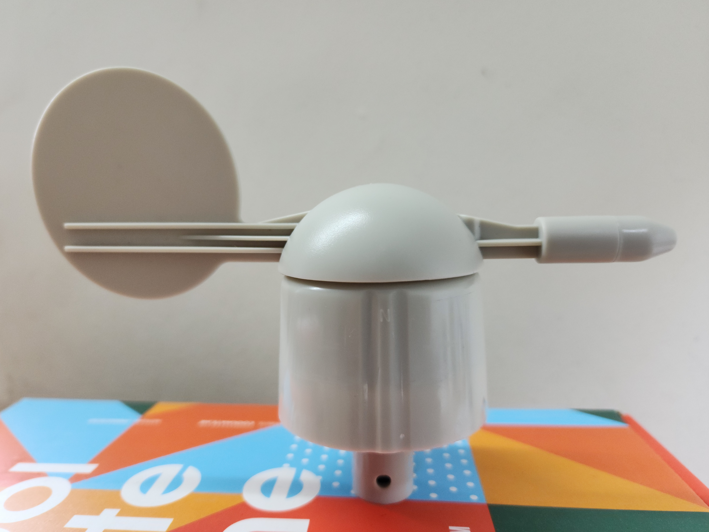

Figure 5‑1. The “N” indicator for North from Figure 2‑5

|  |  |
| --- | --- |
|  |  |
| 1. With an LPF | 1. Without an LPF |

Figure 5‑2. Wind vane test setups

In both tests, the microcontroller reads most wind directions correctly, with the exceptions of 0˚, 67.5˚, 225˚, 292.5˚, and 315˚ for the circuit without a filter, and 270˚, 292.5˚, and 315˚ for the circuit with a filter. In order to analyse the faulty readings, the mixed-up resistance pairs are prepared by sorting the resistance values by direction in the ascending order and calculating the threshold to the upper value of each pair as an average.

|  |  |  |  |  |
| --- | --- | --- | --- | --- |
| Direction pair | | Threshold resistance | % of the lower value | % of the upper value |
| 112.5˚ | - 67.5˚ | 790 Ω | 114.83 | 88.57 |
| 67.5˚ | - 90˚ | 947 Ω | 106.17 | 94.51 |
| 90˚ | - 157.5˚ | 1.201 kΩ | 119.86 | 85.79 |
| 157.5˚ | - 135˚ | 1.795 kΩ | 128.21 | 81.96 |
| 135˚ | - 202.5˚ | 2.655 kΩ | 121.23 | 85.10 |
| 202.5˚ | - 180˚ | 3.5 kΩ | 112.18 | 90.21 |
| 180˚ | - 22.5˚ | 5.22 kΩ | 134.54 | 79.57 |
| 22.5˚ | - 45˚ | 7.375 kΩ | 112.42 | 90.05 |
| 45˚ | - 247.5˚ | 11.145 kΩ | 136.08 | 79.04 |
| 247.5˚ | - 225˚ | 15.04 kΩ | 106.67 | 94.12 |
| 225˚ | - 337.5˚ | 18.94 kΩ | 118.52 | 86.48 |
| 337.5˚ | - 0˚ | 27.5 kΩ | 125.57 | 83.08 |
| 0˚ | - 292.5˚ | 37.585 kΩ | 113.55 | 89.34 |
| 292.5˚ | - 315˚ | 53.485 kΩ | 127.13 | 82.41 |
| 315˚ | - 270˚ | 92.25 kΩ | 142.14 | 77.13 |

Table 9. Thresholds of neighbouring resistance values from Table 1

For the circuit without a LPF, the resulted $R_{WindVane}$ values are from 54.89% to 135.53% the expected values; with the average of 98.32%. The 0˚ and 67.5˚ directions both see only 1 wrong reading each, while the 225˚ returns 13 correct direction results out of 20, and the 292.5˚ direction, as well as 315˚, returns none.

The wrong value in the 0˚ direction is read as 337.5˚ for a value of 24 kΩ, which is below the threshold to be detected as 0˚ from Table 9. The case for 67.5˚ is that the erroneous reading of 947 Ω reaches the threshold of 947 Ω and gets detected as 90˚. For the 225˚ direction, the microcontroller readings oscillate at the threshold over a range of 1.22% to 7.16% above value of expected resistance value, enough to make distinguishing between the 225˚ and the 247.5˚ directions difficult. All readings for the 292.5˚ and 315˚ yield the directions to be 0˚ and 292.5˚, respectively, which raises the question of why the undershooting and overshooting phenomena happen and how the issue could be resolved. Furthermore, despite witnessing the largest undershooting (Figure 5‑3), the 270˚ direction gets detected correctly, which may be thanks to the gap of 54.7 kΩ to its neighbour, the 315˚ direction.

Figure 5‑3. Distribution of wind vane resistance readings from the circuit without a LPF

For the circuit with a LPF, the resulted $R_{WindVane}$ values are from 69.67% to 121.90% the expected values; with the average of 99.64%. Therefore, the first evaluation is that the LPF helps to reduce the overshooting and the undershooting in obtaining the wind vane resistance via an ADC module by shifting the reading results closer to the expected values. Moreover, by comparing Figure 5‑3 and Figure 5‑4, it could be seen that the readings for each direction are more stable due to the reduced gap between the highest and lowest values of each group.

From the test results, there starts to be a distinction between the 0˚ and 292.5˚ directions, as well as the 292.5˚ and 315˚ pair, since oscillations could be observed. This is also an improvement from the circuit without a LPF.

The only issue introduced by the LPF is that the signals at the input of the ADC module get slightly attenuated, to a point where all the values of the 270˚ direction go down below the threshold of the 315˚ - 270˚ pair. According to Table 9, a resistance value must reach 77.13% the expected value for the 270˚ direction, whereas the highest is only 73.58%.

Figure 5‑4. Distribution of wind vane resistance readings from the circuit with a LPF

## Temperature Sensing Units

In this test, the microcontroller reads the temperature from 1 BME280 device and 2 water-proof DS18B20s. The BME280 communicates with the microcontroller via the I2C protocol and is configured following the recommended settings for weather monitoring in [19]. The DS18B20s are both powered externally and put on separate 1-Wire buses; the thermometer resolution of each device is set to 10-bit. The data reference is taken from a digital thermometer FY-11 whose resolution and accuracy, respectively, are 0.1 ℃ and ±1 ℃ [73].

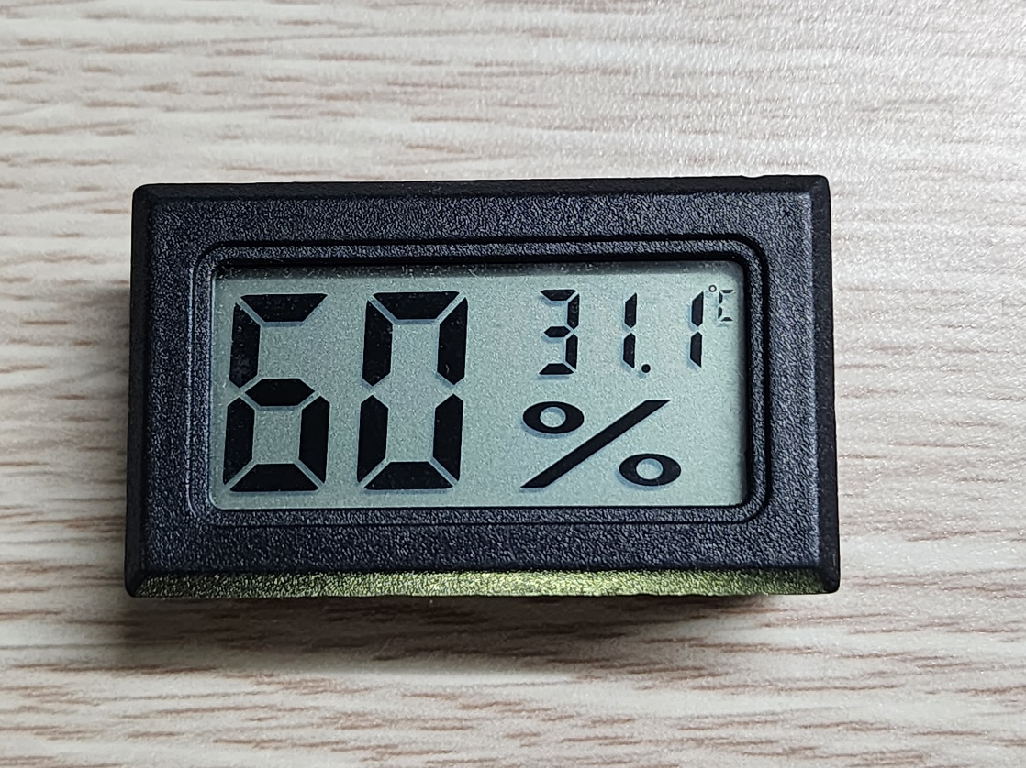

Figure 5‑5. The digital hygrometer – thermometer FY-11 used as reference

The test is performed twice. The first data set consists of 25 entries, while the second has 93. Entries of both sets are recorded approximately 2 minutes apart to reduce timing error by human operations when the BME280 has the lowest data output rate of 1/60 Hz, or 1 sample/minute in weather monitoring mode [19]. For each data entry, the temperature displayed on the reference is input via Serial Monitor to the microcontroller, which then reads the temperature from the sensors and writes to a CSV file on a microSD card.

Figure 5‑6. Temperature sensor behaviours from the first temperature data set

Figure 5‑7. Temperature sensor behaviours from the second temperature data set

The original data sets for Figure 5‑6 and Figure 5‑7 contain the temperature values from the reference FY-11. However, upon building this report is a software defect discovered, which renders the reference entries invalid due to the difference between the input values (floating-point numbers) and the recorded values (integers). The issue does not occur on and affect the recorded temperature data from the BME280 and the DS18B20s. However, without an adequate reference, this test could only compare the temperature sensing units in use.

The BME280 could be seen to produce lower temperature values, up to 0.96 ℃, than the DS18B20s. On the other hand, the data by the BME280 is more stable. During the first run, the smallest temperature change detected by the BME280 is 0.01 ℃, while the largest is 0.72 ℃. The widest gap appears only once between the second and third entries. During the second run, the smallest step remains 0.01 ℃, while the largest is 0.27 ℃. The average temperature change detected by the BME280 from both data sets is 0.05 ℃. The smallest step agrees with the resolution of 0.01 ℃ given in [19].

At the beginning of each run, the ROM code of each DS18B20 is read to distinguish the 2 devices. The temperature difference between the 2 DS18B20s goes up to 0.5 ℃, and the readings by the DS18B20 whose ROM code is 28 AA E7 D1 4D 14 01 20 are always greater than or equal to those by the other sensor. Both detect the temperature change from 0.25 ℃ to 1.5 ℃ per step, with the average of 0.33 ℃. In Figure 5‑7, it is shown that there are some oscillations of 0.25 ℃ between readings of the DS18B20s, which does not happen to the BME208. Since the sampling rate and the resolution of a DS18B20 derived from [24] are, respectively, 1 sample / 187.5 ms and 0.25 ℃, the smallest step of 0.25 ℃ is verified and the oscillation amplitude of 0.25 ℃ is understandable. Should the thermometer resolution be increased, the observed quantities are expected to change accordingly.

## Humidity Sensing Unit

This test is performed simultaneously with the test on temperature sensing units, since the reference FY-11 reads both the temperature and the humidity, like the BME280 sensor. Unlike in the temperature test, the humidity entries by FY-11 are integers due to the 1 %RH resolution [73], thus no problem of conversions from floating-point numbers to integers during card-writing process.

Figure 5‑8. Humidity read by the reference FY-11 and the BME280 sensor in the first run

Figure 5‑9. Humidity read by the reference FY-11 and the BME280 sensor in the second run

In both runs, the BME280 sensor detects humidity change by 0.01 %RH to 1.98 %RH per step, with the exceptions of 3.49 %RH and 3.63 %RH at the beginning of the second run. The average step change is 0.5 %RH. The humidity readings by the BME280 are 0.07 %RH to 2.19 %RH different from those by the hygrometer reference, with the exceptions of 6.92 %RH and 2.43 %RH also at the beginning of the second run. Some oscillations could be observed, especially in Figure 5‑9 due to a longer period of sampling.

Since the hygrometer FY-11 is powered by batteries, it can be considered to have reached saturation before the test. Before the first run, the BME280 has been up for a period of time when software is reviewed and uploaded to the microcontroller. After the first run, the tested system is disconnected from the power source until the second run, when entries are recorded immediately at the beginning. Therefore, it could be assumed that the BME280 needs a period without any operations after being powered in order for the sensing units to initialise properly. Since the entries in this test are taken approximately 2 minutes apart (Section 5.2), it is safe to assume that a such period should be up to 4 minutes.

At this point, the first 2 entries in Figure 5‑9 are discarded. If the humidity by the hygrometer FY-11 was absolute, the mean error of the BME280 humidity readings would be 0.85 %RH. However, the hygrometer FY-11 has an accuracy of 5 %RH [73], and a resolution of 1 %RH, it cannot be used as the reference to determine the humidity accuracy by the BME280, but the reference point for evaluations. The humidity accuracy of the BME280 is then accepted to be ±3 %RH by [19]. Moreover, since the minimum resolution of 0.01 %RH is just a rounded number to 2 floating points, and is obtained at the interval higher than the output rate of the BME280 in weather monitoring mode in this test, it is also safe to accept the resolution of 0.008 %RH given by Bosch Sensortec [19].

## InfluxDB Online Database

The InfluxDB database is tested for accessibility and success rate of data uploading. The nodeMCU ESP8266 shown in Section 2.6 is used to obtain the sensor readings by a BME280 and update the online database.

At the beginning of the test, after the hardware connections are established between the BME280 sensor and the nodeMCU, a software containing a Wi-Fi network’s credentials and access APIs to an existing InfluxDB bucket is uploaded to the nodeMCU. The hardware is then set aside to run autonomously.

In the meantime, the data uploading process is tracked on the Serial Monitor. A dashboard displaying sensor readings is created on the InfluxDB web interface of the bucket for observations of uploaded sensor reading. By software, the nodeMCU updates the online database once every 10 seconds. After 1 hour, the test is stopped manually and the results are analysed.

The dashboard is set to refresh every second. Therefore, whenever the nodeMCU uploads an entry, the graphs are updated instantaneously. Within the 1-hour window, the dashboard is observed to receive all the entries from the nodeMCU, which yields the success rate of data uploading to 100%. The spike on the relative humidity graph is expected after the BME280 is covered in the palm of a hand to create a sudden rise in humidity readings.

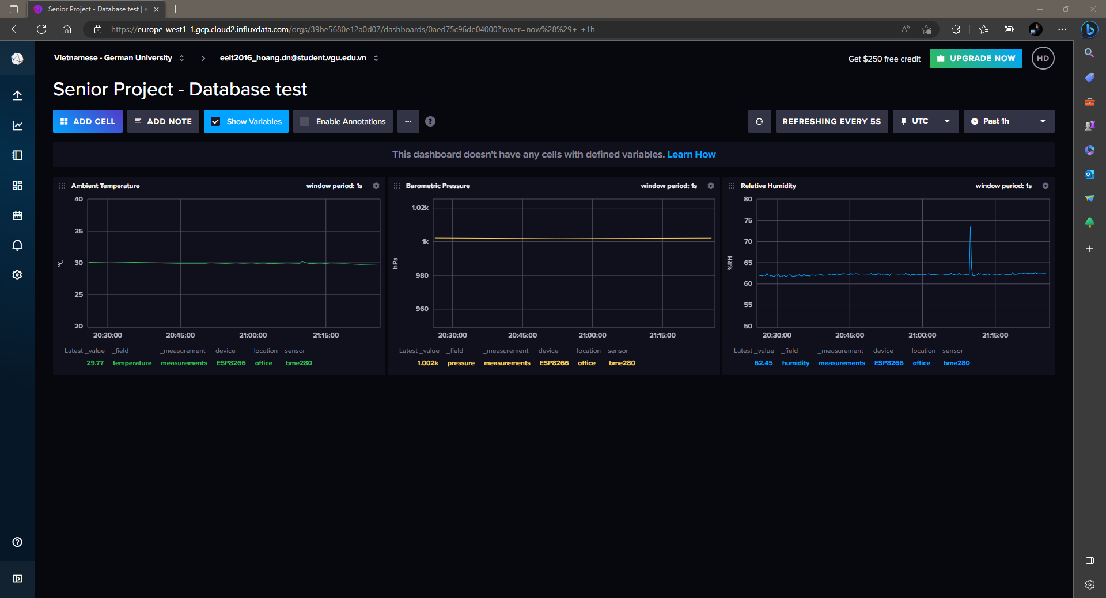

Figure 5‑10. The InfluxDB dashboard displaying sensor readings from BME280

# Conclusion and Future Work

The conceptual design of an Autonomous Wireless Agrometeorology Station introduces a new solution for improvements of agricultural production via monitoring the meteorological factors, including wind parameters, precipitations, temperature, humidity, and atmospheric pressure. However, this design remains incomplete due to testing limitations.

The available results suggest that the digital sensors are reliable, and remote data access in real time is possible with InfluxDB. By concept, the analogue sensors for wind and rain data could produce adequate data with suitable circuitries and software. Further evaluations on each module are required to improve the current setups and advance to build a working protype.

For the time being, the work to be done includes:

* Evaluation of the anemometer. Although testing equipment is currently unavailable, the aerodynamics of movements in an open space may be investigated to build alternative test conditions.
* Improvement of wind vane resistance readings. The analogue LPF has been proved to improve the readings from the wind vane, yet errors persist. A digital filter may be a solution for the existing issues.
* Evaluation of the rain gauge. The working principles of a traditional rain gauge are to be studied to build adequate test conditions for a tipping bucket.
* Further evaluations of the digital sensors.
* Thorough evaluations of the SX1278 LoRa modules, including tests on signal coverage, data rate, drop rate, power consumption, etc.
* Development and evaluation of the system powering unit, which contains a solar panel and battery storage system.
* Integration of all modules on a single prototype and move from a concept to a real design.

# References

[1] H. N. Do, “Conceptual Design of an Autonomous Wireless Agrometeorology Station,” 2023.

[2] E. Fahad, “Microcontroller Selection Criteria for your project, 8 bit Vs 16 bit Microcontroller,” *Electronic Clinic*, 2021. https://www.electroniclinic.com/microcontroller-selection-criteria-for-your-project-8-bit-vs-16-bit-microcontroller/.

[3] J. Koon, “Key factors to consider when choosing a microcontroller,” *Micrcontroller Tips*, 2019. https://www.microcontrollertips.com/key-factors-consider-choosing-microcontroller/.

[4] EntcEngg Team, “Criteria for Choosing a Microcontroller.” 2017, [Online]. Available: https://www.entcengg.com/criteria-choosing-microcontroller/.

[5] Robocraze, “How to choose a microcontroller,” *Robocraze*, 2021. https://robocraze.com/blogs/post/selecting-a-microcontroller-for-your-projects.

[6] Texas Instruments, “Benefits and Issues on Migration of 5-V and 3.3-V Logic to Lower-Voltage Supplies,” 1999. [Online]. Available: https://www.ti.com/lit/an/sdaa011a/sdaa011a.pdf.

[7] STM32-base, “Blue Pill,” *STM32-base*. https://stm32-base.org/boards/STM32F103C8T6-Blue-Pill.html.

[8] STMicroelectronics, “STM32F101xx, STM32F102xx, STM32F103xx, STM32F105xx and STM32F107xx advanced Arm®-based 32-bit MCUs,” no. February 2021. 2021.

[9] STMicroelectronics, “STM32F103x8, STM32F103xB.” pp. 1–116, 2022.

[10] M. Cardinali, “The importance of weather data in agriculture,” *Agricolus*, 2022. https://www.agricolus.com/en/the-importance-of-weather-data-in-agriculture/.

[11] B. Gardiner, P. Berry, and B. Moulia, “Review: Wind impacts on plant growth, mechanics and damage,” *Plant Sci.*, vol. 245, pp. 94–118, Apr. 2016, doi: 10.1016/j.plantsci.2016.01.006.

[12] E. de Langre, “Effects of Wind on Plants,” *Annu. Rev. Fluid Mech.*, vol. 40, no. 1, pp. 141–168, Jan. 2008, doi: 10.1146/annurev.fluid.40.111406.102135.

[13] Misol Electronics, “misol SP-WS02 Spare part (outdoor unit) for Professional Wireless Weather Station.” http://www.misolweather.com/index.php?m=home&c=View&a=index&aid=60.

[14] S. Pindado, J. Cubas, and F. Sorribes-Palmer, “The Cup Anemometer, a Fundamental Meteorological Instrument for the Wind Energy Industry. Research at the IDR/UPM Institute,” *Sensors*, vol. 14, no. 11, pp. 21418–21452, Nov. 2014, doi: 10.3390/s141121418.

[15] Argent Data System, “Weather Sensor Assembly p / n 80422.” 2014, [Online]. Available: https://www.argentdata.com/files/80422_datasheet.pdf.

[16] T. Reed, “Multimeter Measurements Explained,” *Electronic Design*, 2020.

[17] Misol Electronics, “Professional Weather Station (Wind and Air Pressure) - Operational Manual.” pp. 1–24.

[18] Bosch Sensortec GmbH, “Humidity sensor BME280,” *Bosch Sensortec GmbH*. https://www.bosch-sensortec.com/products/environmental-sensors/humidity-sensors-bme280/#description.

[19] Bosch Sensortec GmbH, “BME280 Environmental Sensor,” *Bosch Sensortec GmbH*. Jan. 2022.

[20] TE Connectivity, “Pressure, Humidity and Temperature Combination Sensor.” https://www.te.com/usa-en/product-CAT-BLPS0018.html.

[21] Thegioiic, “BME280 High Precision Atmospheric Pressure Sensor.” https://www.thegioiic.com/bme280-mach-cam-bien-ap-suat.

[22] Bosch Sensortec GmbH, “Bosch Sensortec BME280 sensor driver.” [Online]. Available: https://github.com/boschsensortec/BME280_driver.

[23] C. Petrich, N. P. Dang, I. Sæther, Ø. Kleven, and M. O’Sadnick, “A Note on Remote Temperature Measurements with DS18B20 Digital,” 2020, [Online]. Available: https://hdl.handle.net/11250/2716073.

[24] Maxim Integrated, “DS18B20.” 2019, [Online]. Available: https://datasheets.maximintegrated.com/en/ds/DS18B20.pdf.

[25] M. Fezari and A. Al Dahoud, *Exploring One-wire Temperature sensor “DS18B20” with Microcontrollers*. 2019.

[26] S. Budijono and Felita, “Smart Temperature Monitoring System Using ESP32 and DS18B20,” *IOP Conf. Ser. Earth Environ. Sci.*, vol. 794, no. 1, p. 012125, Jul. 2021, doi: 10.1088/1755-1315/794/1/012125.

[27] Widodo and E. A. Stiyawan, “Design of Total Dissolve Solid (Tds) Measuring Using Conductivity Sensor and Temperature Sensor Ds18B20,” *BEST J. Appl. Electr. Sci. Technol.*, vol. 2, no. 1, pp. 25–29, 2020, doi: 10.36456/best.vol2.no1.2583.

[28] Process Parameters Ltd, “HOW TO CALIBRATE PT100 TEMPERATURE SENSOR,” *Process Parameters Ltd*. https://www.processparameters.co.uk/how-to-calibrate-pt100/.

[29] Thegioiic, “DS18B20-1M Digital Temperature Sensor.” https://www.thegioiic.com/ds18b20-day-cam-bien-nhiet-do-1m.

[30] Thegioiic, “AM2315 Temperature And Humidity Module.” https://www.thegioiic.com/am2315-cam-bien-nhiet-do-do-am.

[31] B. Linke, “Reading and Writing 1-Wire® Devices Through Serial Interfaces,” 2009.

[32] Texas Instruments, “Implementing 1-Wire Enumeration for TMP1826 With TM4C129x Microcontrollers.” 2018, [Online]. Available: https://www.ti.com/lit/an/spma057d/spma057d.pdf.

[33] Speedtest® by Ookla®, “Speedtest Global Index,” *Speedtest® by Ookla®*. https://www.speedtest.net/global-index/vietnam.

[34] B. Mitchell, “What is the Range of a Typical Wi-Fi Network?,” *Lifewire*. 2020, [Online]. Available: https://www.lifewire.com/range-of-typical-wifi-network-816564%0Ahttp://compnetworking.about.com/cs/wirelessproducts/f/wifirange.htm.

[35] J. G. Sponås, “Things You Should Know About Bluetooth Range,” *Get Connected Blog*, 2023. https://blog.nordicsemi.com/getconnected/things-you-should-know-about-bluetooth-range.

[36] A. Lavric and V. Popa, “Performance Evaluation of LoRaWAN Communication Scalability in Large-Scale Wireless Sensor Networks,” *Wirel. Commun. Mob. Comput.*, vol. 2018, pp. 1–9, Jun. 2018, doi: 10.1155/2018/6730719.

[37] A. Ambanloc, “What Communication Protocol to Use and When,” *NeuronicWorks*. https://neuronicworks.com/blog/wireless-communication-protocols/.

[38] Voler Systems, “Wireless Communication Choices for IoT Designs,” *Voler Systems*. https://www.volersystems.com/blog/wireless-communication-choices-for-iot-designs.

[39] EPB, “How Far Will Your Wi-Fi Signal Reach?,” *EPB.com*. https://epb.com/get-connected/gig-internet/how-far-will-your-wi-fi-signal-reach/.

[40] Tessie, “HC-06 vs. HC-05 Bluetooth Module: What is the difference between HC-06 and HC-05?,” *Utmel Electronics*, 2021. https://www.utmel.com/components/hc-06-vs-hc-05-bluetooth-module-what-is-the-difference-between-hc-06-and-hc-05?id=889.

[41] A. Wang, “Comparison between LoRa and other wireless technologies,” *MOKOLoRa*, 2021. https://www.mokolora.com/lora-and-wireless-technologies/.

[42] Thegioiic, “Zigbee Modules.” https://www.thegioiic.com/product/mach-zigbee.

[43] Thegioiic, “RF Transceivers.” https://www.thegioiic.com/product/mach-thu-phat-rf.

[44] Semtech, “Semtech SX1276,” *Wirel. Sens. Prod.*, no. May, 2020, [Online]. Available: https://www.semtech.com/products/wireless-rf/lora-core/sx1276.

[45] HeyPete, “Major differences between the DS3231 and DS3231M RTC chips.” 2017, [Online]. Available: https://blog.heypete.com/2017/09/05/major-differences-between-the-ds3231-and-ds3231m-rtc-chips/.

[46] HeyPete, “DS3231 Drift Results (5 months).” 2018, [Online]. Available: https://blog.heypete.com/2018/02/04/ds3231-drift-results-5-months/.

[47] Maxim Integrated, “DS3231.” 2015.

[48] Omega Engineering, “Sources of Noise and Some Typical Solutions,” *Omega Engineering*. https://www.omega.co.uk/techref/das/noise.html.

[49] J. Heath, “Electrical noise can come from anywhere,” *Analog IC Tips*, 2021. https://www.analogictips.com/electrical-noise-can-come-from-anywhere/.

[50] V. Muthukrishnan, “Cutoff Frequency: What is it? Formula And How To Find it,” *Electrical4U*, 2022. https://www.electrical4u.com/cutoff-frequency/.

[51] SparkFun, “Pull-up Resistors,” *SparkFun*. https://learn.sparkfun.com/tutorials/pull-up-resistors/all (accessed Jul. 26, 2023).

[52] J. Christoffersen, “Switch Bounce and How to Deal with It,” *All About Circuits*, 2015. https://www.allaboutcircuits.com/technical-articles/switch-bounce-how-to-deal-with-it/.

[53] Texas Instruments, “Debounce a Switch.” 2020.

[54] Mid-West Instrument, “Reed Switches General Info.” https://www.midwestinstrument.com/tech-info/switch-considerations/reed-switches-general-info/.

[55] N. Kularatna, A. S. Ross, J. Fernando, and S. James, “Background to Surge Protection,” in *Design of Transient Protection Systems*, Elsevier, 2019, pp. 1–15.

[56] I. Advanced Monolithic Systems, “AMS1117 1A LDO Voltage Regulator,” *Datasheet*. 2009.

[57] L. Kristensen, “Cups , Props and Vanes,” Roskilde, 1994.

[58] Windy.app, “Where wind gusts come from,” *Windy.app Meteorological Textbook*. https://windy.app/textbook/where-wind-gusts-come-from.html.

[59] Raspberry Pi Foundation, “Build your own weather station.” https://projects.raspberrypi.org/en/projects/build-your-own-weather-station/0.

[60] Australian Bureau of Meteorology, “Observation of rainfall.” http://www.bom.gov.au/climate/cdo/about/rain-measure.shtml.

[61] Ladyada, “Adafruit_BME280_Library.” [Online]. Available: https://github.com/adafruit/Adafruit_BME280_Library.

[62] PJRC, “OneWire Library,” *PJRC*. https://www.pjrc.com/teensy/td_libs_OneWire.html.

[63] M. Centenaro, L. Vangelista, A. Zanella, and M. Zorzi, “Long-range communications in unlicensed bands: the rising stars in the IoT and smart city scenarios,” *IEEE Wirel. Commun.*, vol. 23, no. 5, pp. 60–67, Oct. 2016, doi: 10.1109/MWC.2016.7721743.

[64] The Things Network, “What are LoRa and LoRaWAN?,” *The Things Network*. https://www.thethingsnetwork.org/docs/lorawan/what-is-lorawan/.

[65] V. Q. Tran, “Evaluate The Effectiveness Of Lora Network For Data Collection,” 2022.

[66] R. P. Centelles, F. Freitag, R. Meseguer, and L. Navarro, “Beyond the Star of Stars: An Introduction to Multihop and Mesh for LoRa and LoRaWAN,” *IEEE Pervasive Comput.*, vol. 20, no. 2, pp. 63–72, Apr. 2021, doi: 10.1109/MPRV.2021.3063443.

[67] D. Kjendal, “LoRa-Alliance Regional Parameters Overview,” *J. ICT Stand.*, vol. 9, no. 1, pp. 35–46, Apr. 2021, doi: 10.13052/jicts2245-800X.914.

[68] The Things Network, “Frequency Plans by Country,” *The Things Network*. https://www.thethingsnetwork.org/docs/lorawan/frequencies-by-country/.

[69] LORIOT, “LoRaWAN Network Server v7.x (Osprey) - Global Frequency Plans,” *LOIOT*. https://docs.loriot.io/display/LNS/Global+Frequency+Plans.

[70] Heltec Automation, “LoRaWAN Frequency Plans,” *Heltec Automation*. https://docs.heltec.org/general/lorawan_frequency_plans.html.

[71] S. Mistry, “Arduino LoRa.” GitHub, [Online]. Available: https://github.com/sandeepmistry/arduino-LoRa.

[72] A. D. Wickert, C. T. Sandell, B. Schulz, and G.-H. C. Ng, “Open-source Arduino-compatible data loggers designed for field research,” *Hydrol. Earth Syst. Sci.*, vol. 23, no. 4, pp. 2065–2076, Apr. 2019, doi: 10.5194/hess-23-2065-2019.

[73] Thegioiic, “FY-11 Digital LCD Thermometer Hygrometer.” https://www.thegioiic.com/fy-11-dong-ho-nhiet-do-do-am.